 

**CairoUniversity**

**Faculty of Graduate Studies for Statistical Research Department of Software Engineering**

**Cairo University**

**Study of the effect of alcoholic beverages on the driving patterns of adult drivers**

A Thesis Submitted in Partial Fulfillment of the Requirements for the Degree of Master in Software Engineering

**by**

**Mohamed Salah Ibrahim**

**Supervised by**

Prof. Mervat Gheith Dr.Tarek Aly

**20**

# Abstract:

The Influence of Alcohol on Driver Patterns: Early Detection Using Machine Learning

Driving under the influence of alcohol remains a critical factor contributing to road accidents and jeopardizing road safety globally. This study delves into the impact of alcohol on driver behavior patterns and introduces an innovative method to preemptively identify these patterns using a machine learning model. The primary goal is to establish an early warning system capable of alerting drivers about their compromised driving abilities due to alcohol consumption, thus mitigating potential accidents.

To facilitate this research, an extensive dataset was curated from diverse sources, including driving simulators and real-world driving scenarios. This dataset encompassed a wide spectrum of driving behaviors under varying levels of alcohol influence. Feature extraction involved parameters such as vehicle speed, lane deviation, and reaction times.

Through rigorous experimentation, a machine learning framework was devised to analyze the dataset and recognize distinctive patterns that signify alcohol-induced impairment. A comprehensive array of algorithms, including decision trees, clusters, and neural networks, underwent evaluation to determine the optimal model for detection. The chosen model was fine-tuned and validated using cross-validation techniques.

The resulting system adeptly detects patterns that indicate alcohol-related impairment in real-time. By scrutinizing driver behavior and their interactions with the vehicle, the model accurately predicts instances of alcohol influence. Upon identifying a heightened likelihood of impairment, the system issues a prompt warning to the driver, highlighting their compromised state and recommending appropriate actions such as refraining from driving or seeking alternative transportation.

This study substantiates that the machine learning model significantly contributes to curbing alcohol-related accidents by providing preemptive alerts to impaired drivers. The efficacy of the model hinges on the quality and diversity of the training dataset, along with the accuracy of input data. Future research endeavors could concentrate on expanding the dataset to encompass a broader array of scenarios and validating the model extensively in real-world settings.

In conclusion, this study introduces a promising approach to tackling the perils associated with alcohol-impaired driving. By harnessing machine learning techniques for real-time assessment, the proposed system presents a proactive strategy to enhance road safety and avert potential accidents triggered by alcohol influence.

Keywords: alcohol-impaired driving, driver behavior patterns, real-time detection, machine learning model, road safety, early warning system, vehicle speed, lane deviation, reaction times, decision trees, random forests, support vector machines, neural networks, training dataset, real-world scenarios, road accidents, proactive solution.

# Table of Contents

Abstract: 7

Table of Contents 8

List of Figures 10

List of Tables 11

Acknowledgement 12

**Introduction 13**

1.1 A problem statement: 14

1.2 Thesis objectives 14

1.3 Research Methodology: 16

1.4 Thesis layout: 18

**Related Works 19**

2-1 Introduction: 19

2-2 Driver Profile and Driving Pattern Recognition for Road Safety Assessment: Main Challenges and Future Directions: 19

2-3 A Review for the Driving Behavior Recognition Methods Based on Vehicle Multisensor Information 20

2-4 Drank D riving Detection 21

**The Proposed Solution For Detect Abnormal Drivers Pattern 22**

3.1 Introduction 22

3.2 Generate And Collecting The Data From Simulator. 22

3.3 Chose Algorithm To Build An AI Model. 26

3.3.1Define Different Algorithms 27

3.3.2Test And Evaluate Each One 33

3.3.3 Chose Most Effective and Applicable Algorithm 36

3.4 Design Solution Architecture: 36

3.4.1 Context diagram: 36

3.4.2 Component diagram: 37

3.4.3 Technology diagram: 38

3.4.4 Sequence diagram: 39

**Results and Evaluation 41**

4.1 Introduction: 41q

**Conclusions 45**

**References: 47**

# List of Figures

Figure (1) Architecture of the system 24

Figure (1) Time series computation of frequency fluctuation 24

Figure (1) Car Simulator I 24

Figure (1) Car Simulator I 24

Figure (2) Car Simulator II 25

Figure (3) Real Car wheel Connected To Web Simulator 25

Figure (4) Real Car wheel Connected To Web Simulator 26

Figure (5) Cluster Algorithm 28

Figure (6) KNN Algorithm 29

Figure (7) Neural Networks Algorithm 30

Figure (8) Logistic Regression Algorithm 32

Figure (7) Neural Networks Algorithm 30

Figure (8) Logistic Regression Algorithm 31

Figure (9) Support Vector Machine Algorithm 32

Figure (10) Naive Bayes Algorithm 33

Figure (11) Models Training Process 34

Figure (12) Right Data 35

Figure (13) Wrong Data 35

Figure (14) All Data 36

Figure (15) Context diagram 38

Figure (16) Component diagram 39

Figure (17) Technologies diagram 40

Figure (18) Sequence diagram 41

Figure (19) Confusion Matrix 43

Figure (20) The Schematic Diagram Of Controller Structure 45

# List of Tables

|  |  |  |
| --- | --- | --- |
| Table (1) | Comparison between Different Machine Learning Models | 37 |
| Table (2) | Confusion Matrix real data implementation for Naive Bayes Algorithm | 48 |
| Table (3) | Confusion Matrix real data implementation for Naive Bayes Algorithm | 48 |
| Table (4) | Confusion Matrix real data implementation for Neural Network Logistic Activation Algorithm | 49 |
| Table (5) | Confusion Matrix Measure for Neural Network Logistic Activation Algorithm | 49 |
| Table (5 | Actual Results from real users use (DPObserver) Solution | 50 |

# Acknowledgement

First of all, ultimate thanks are due to Allah, who without he is, and this work could not be done.

I am making this thesis not only for degree but to also increase my knowledge.

I would like to express my special thanks of gratitude to my supervisors Dr/ Mervat Gheith and Dr/ Tarek Aly who gave me the golden opportunity to do this wonderful thesis, which also helped me in doing a lot of Research and i came to know about so many new things I am thankful to them.

I would also like to thank my family and friends who helped me a lot in finalizing this thesis within the limited time frame.

I would also like to thank the whole development team members whom I worked with during my research activities.

Finally, I apologize to all other unnamed who helped me in various ways to have a good thesis.

### Introduction

Driving under the influence of alcohol remains a significant public health concern that poses a danger to both the driver and other road users. In Asia alone, 400,000 people are killed on the roads annually and more than four million injured (Transport and Research Laboratory, UK, 1998) in the US, around 30 people die each day in traffic crashes in which one of the parties is under the influence of alcohol, and, together, alcohol-related crashes amount to **30%** of all traffic fatalities (2020 National Highway Traffic Safety) Previous studies have shown that even low blood alcohol concentrations (BACs) can impair critical driving skills such as According to the latest available data, Egypt has experienced a substantial number of road Recent statistics released by the Central Agency for Public Mobilization and Statistics (CAPMAS) highlight the severity of this issue, with a total of **5,686** road accidents occurring across Egypt in 2022 alone. This alarming figure accentuates the critical need for evidence-based interventions to enhance road safety and reduce the burden of traffic-related traumas (CAPMAS, 2022). re underscores the urgent need for comprehensive strategies aimed at improving road safety and reducing the incidence of traffic-related fatalities and injuries, the security of connected cars will become more important as more cars are connected to the Internet. Gartner reports that there will be a quarter of a billion connected vehicles by 2020 (Gartner reports, 2015) drivers with a BAC of 0.08 g/dL or higher are at a significantly higher risk of being involved in a fatal crash than sober adult drivers (Waller et al, 2019). The physiological effects of alcohol on the human body can impair driving performance by affecting crucial skills such as coordination, reaction time, and decision-making, particularly among adult drivers (Mandel et al., 2018). Despite numerous campaigns and legislation aimed at reducing the incidence of drunk driving, it remains a leading cause of road accidents and fatalities among adult drivers worldwide.

Figure (1) Percentage of accidences under alcohol effect compare than total accidences (National Highway Traffic Safety).

In recent years, advances in machine learning algorithms have made it possible to detect patterns in adult driver behavior that could indicate impaired driving and alert drivers to prevent accidents before they happen. This research aims to explore the use of machine learning algorithms to detect patterns in adult driver behavior that could indicate impaired driving and alert adult drivers in real-time. By leveraging data from sensors in the car, such as accelerometers and gyroscopes, as well as data from the adult driver's smartphone and other wearable devices, we can develop models that detect changes in driving behavior that may indicate impairment among adult drivers. The goal of this research is to develop a system that can alert adult drivers in real-time to prevent accidents before they happen and promote safer driving practices among adult drivers.

#### A problem statement:

Driving under the influence of alcohol remains a significant contributor to road accidents and poses a severe threat to road safety worldwide. Despite numerous awareness campaigns and legal measures, alcohol-impaired driving continues to endanger lives. The lack of effective preemptive systems to identify and alert drivers about their compromised state due to alcohol consumption perpetuates this problem. Existing methods often rely on post-incident investigations or self-assessment, leading to delayed responses and potential accidents. This study aims to address this issue by investigating the influence of alcohol on driver behavior patterns and developing a machine learning-based early detection system. analyzing driver’s running pattern is a good way to authenticate the driver (Enev et al, 2016). Previous works collected driving data from cars and used it in driver profiling,The goal is to proactively identify and warn drivers about their impaired abilities before accidents occur, ultimately contributing to a safer road environment and reducing the impact of alcohol-related accidents.

#### Thesis objectives

The primary objective of this study is to design and implement a Machine Learning Model able to learn different patterns and early detect abnormal driving patterns through the software "DPObserver" that can detect and alert the driver and police. Specifically, the study aims to:

Investigate Alcohol's Impact: Analyze the influence of alcohol on driver behavior patterns by studying simulation driving scenarios under varying levels of alcohol consumption.

Feature Extraction: Extract relevant features from the dataset, including vehicle speed, lane deviation, and reaction times, to quantify and characterize driver behavior patterns.

Model Selection and Development: Evaluate various machine learning algorithms, such as decision trees, Cluster, and neural networks, to identify the most effective model for pattern detection.

Model Training and Validation: Train the selected machine learning model on the curated dataset and fine-tune its parameters. Validate the model's performance using cross-validation techniques to ensure its reliability and generalization.

Real-time Detection: Implement the trained model in a real-time monitoring system that analyzes incoming driving behavior data and predicts instances of alcohol-impaired patterns.

Early Warning System: Integrate the detection system with an early warning mechanism that alerts drivers in real time when their behavior indicates alcohol-related impairment.

Scalability and Robustness: Explore the system's scalability by evaluating its performance on a larger scale and in different driving scenarios. Enhance the system's robustness by considering various real-world conditions.

Contribution to Road Safety: Evaluate the potential impact of the developed system on reducing alcohol-related accidents and enhancing overall road safety.

By achieving these objectives, this study aims to contribute to the prevention of alcohol-impaired driving incidents and promote safer road environments through proactive detection and timely interventions.

#### Research Methodology:

This study employs a comprehensive research methodology that encompasses several key stages: data collection, model development, validation, and evaluation. The methodology is meticulously crafted to achieve the objectives of the study, which are investigating the influence of various factors on driver patterns and developing an early detection system for abnormal driving behavior using advanced machine learning techniques. The methodology comprises the following steps:

**Data Collection:**

**Real User Data:** Data is collected from real users via sensors embedded in their smartphones. These sensors capture a range of parameters related to the driver's behavior, such as acceleration, speed, and geographical location. This approach enables the gathering of rich, real-world driving pattern data under varied conditions and scenarios.

**Simulation Data**: In addition to real-world data, simulated driving data is also employed. This data is generated through computer simulations that model vehicle movement on pre-defined paths. The simulation allows for the control of environmental variables and the replication of specific driving scenarios that may not be easily captured through real-world data collection.

Extract relevant features such as vehicle speed, lane deviation, and reaction times from the collected data.

**Exploratory Data Analysis:**

Conduct exploratory data analysis to understand the characteristics of the collected dataset.

Identify patterns and correlations between driving behaviors and alcohol influence levels by my AI model.

**Model Selection and Development:**

Evaluate multiple machines learning algorithms, including decision trees, random forests, support vector machines, and neural networks, for pattern detection.

Select the most suitable algorithm based on performance metrics and model complexity.

**Model Training and Validation:**

Split the dataset into training and validation sets for model training and evaluation.

**Real-time Implementation:**

Develop a real-time monitoring system that continuously analyzes incoming driving behavior data.

Integrate the trained machine learning model into the system for detecting alcohol-impaired patterns.

**Early Warning System:**

Design an early warning mechanism that triggers alerts when the model identifies alcohol-impaired driving patterns.

Determine appropriate thresholds for issuing warnings to drivers.

**Ethical Considerations:**

Address ethical considerations related to privacy and data security in collecting and using driving behavior data Ensure transparency in explaining the system's functioning to users.

**Contribution to Road Safety:**

Analyze the potential impact of the developed system on reducing alcohol-related accidents and enhancing road safety.

Through this research methodology, the study aims to advance our understanding of alcohol's influence on driver behavior patterns and provide a practical solution to mitigate the dangers of alcohol-impaired driving through real-time pattern detection and early warnings.

#### Related Works

#### Introduction:

The field of transportation and vehicle behavior analysis, coupled with studies on the impact of alcohol on driver behavior, has witnessed significant advancements in recent years. Researchers have explored various facets of these domains, ranging from studies on driver safety, driving pattern analysis, and eco-driving, to investigations into the effects of alcohol on cognitive and motor skills in the context of driving. In order to gain a deep understanding of the evolution and current state of research in these interrelated fields, we have undertaken a thorough review of the literature this section offers two main studies that are directly relevant to our study's dual focus on driving patterns and their association with influence alcohol.

#### Driver Profile and Driving Pattern Recognition for Road Safety Assessment: Main Challenges and Future Directions:

This research thoroughly reviewed artificial intelligence and machine learning Methods used so far in driver profile and driving style Recognition studies for traffic safety analysis purposes. The goal was to identify the best methodology and data collection and suggest future directions for enhancing macroscopic understanding microscopic aspects of driving behavior and thus the road safety.

One of the most important findings of this study is the ambiguity in defining the two scientific fields. It is to discover what the most efficient driving metrics should be used in similar research and repeated data collection it should depend on the level of analysis. Furthermore, she noted the levels of analysis used to define groups of the common behaviors, they can be classified as macroscopic,

Macroscopic (Driving safety, 2019), (Temporal analysis, 2021) and microscopic depending on the level of information they use. Conspicuous absence a methodological framework for identifying macroscopic driver profiles and microscopic driving patterns it is proposed to address them through a methodology that combines macroscopic and microscopic driving metrics, respectively volume 4, 2023 97 TSELENTIS and PAPADIMITRIOU: Driver profile and driving style recognition.

#### A Review for the Driving Behavior Recognition Methods Based on Vehicle Multisensor Information

Since abnormal driving behaviors may lead to immediate accidents, how to improve the identification efficiency and develop a lightweight model that can accurately identify driving behaviors.

This paper reviews and summarizes driving behavior recognition methods based on vehicle sensor information fusion. On-board sensor data contain a wealth of information about driving behavior; Based on the two main factors of driving behavior and vehicle control, driving behavior information can be divided into driver state information, driver control state information, vehicle control state information, vehicle state information, road environment state information, as well as the corresponding data acquisition system. The characteristics of joint data level, feature level and decision-level information fusion methods are analyzed to guide the selection of appropriate information fusion methods and the basic principles and main characteristics of feature extraction methods. Driving behavior recognition methods are classified into traditional machine learning methods and deep learning methods. Random forest, support vector machine is presented, and applied in fatigue, distraction, following, lane change, and other driving behavior recognition. The application of convolutional neural network (CNN) and recurrent neural network (RNN) in building driving behavior recognition models is analyzed. The characteristics of the four leadership behavior recognition paradigms described in this paper are briefly summarized.

Driving behavior is greatly influenced by the driver's condition, and the driving behavior exhibited by the same driver may vary significantly. At the same time, driving behavior is also susceptible to the influence of the road, environment and vehicle, so there are some uncertainties. How to improve the power and generalization ability of the driving behavior recognition model still needs further study.

Drunk Driving Detection

#### Drank Driving Detection

Although there has been significant work on drunk driving, this work...

It focuses largely on statistical analysis that examines the effect.

The effect of alcohol on driving performance (S. Jongen, E. F. P. M. Vuurman, 2016). These empirical results provide a basis for regulators to decide on the relevant legal limits to drive under

Effect of alcohol [28]. However, these previous works did not do this

Focus on real-time identification of drunk driving, which would

Allowing intervention when the driver is already drunk. Previous research

It also addressed the negative effect of alcohol on gaze behavior while looking .

Unfortunately, the results of this experimental study present an increase in the condition of diabetes

Leadership (Huiqin Chen and Lei Chen. 2017.) teaches that, while magic

Driver control training works well on previously employed drivers, but it does not achieve the performance required to generalize to unseen drivers.

#### Drunk Driving Detection Based on Engine Locking System

A drunk driving detection system based on the ignition interlock system is used to detect whether a person is drunk or not, and if the person is drunk, the system prevents him from driving and informs the nearest police station of the detection of an alcoholic driver. This system monitors the behavior of vehicles inside and outside the car (Rahul Mandalkar,2015). This system also notifies the ambulance and the driver's relatives if an accident occurs.

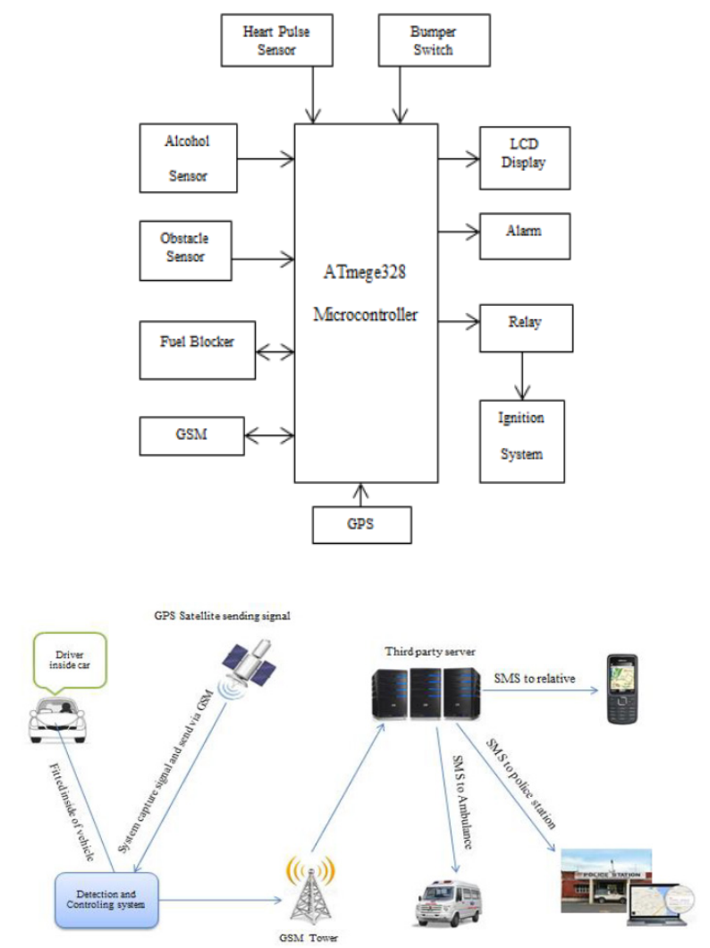

Figure (1) Architecture of the Engine Locking System

When the driver starts the car, the alcohol sensor (MQ-3) begins to sense that the car's speed is zero. If the driver is detected to be intoxicated, the ignition system will be turned off immediately with an alarm issued and the police station will be reported. A mark is made when the first condition is passed without detecting alcohol. When the vehicle speed is greater than zero, i.e. when the vehicle is in motion, the alcohol sensor starts sensing and sends the collected parameter values to the microcontroller. If it is detected drunk in this state, the signal will be sent to the fuel inhibitor by the microcontroller to block fuel supply to the ignition system. It also alerts the driver via an alert, and the car is stopped at that location with the police station notified.

#### Drunk Driving Detection Using Driving Pattern

Drunk driving pattern detection using driving patterns Driving drunk driving pattern detection using driving patterns uses mobile phones as a platform to detect drunk driving because it combines detection and communication functions (Jiangpeng Dai, Jin Teng,2010). As a standalone device, the mobile phone presents a mature device.

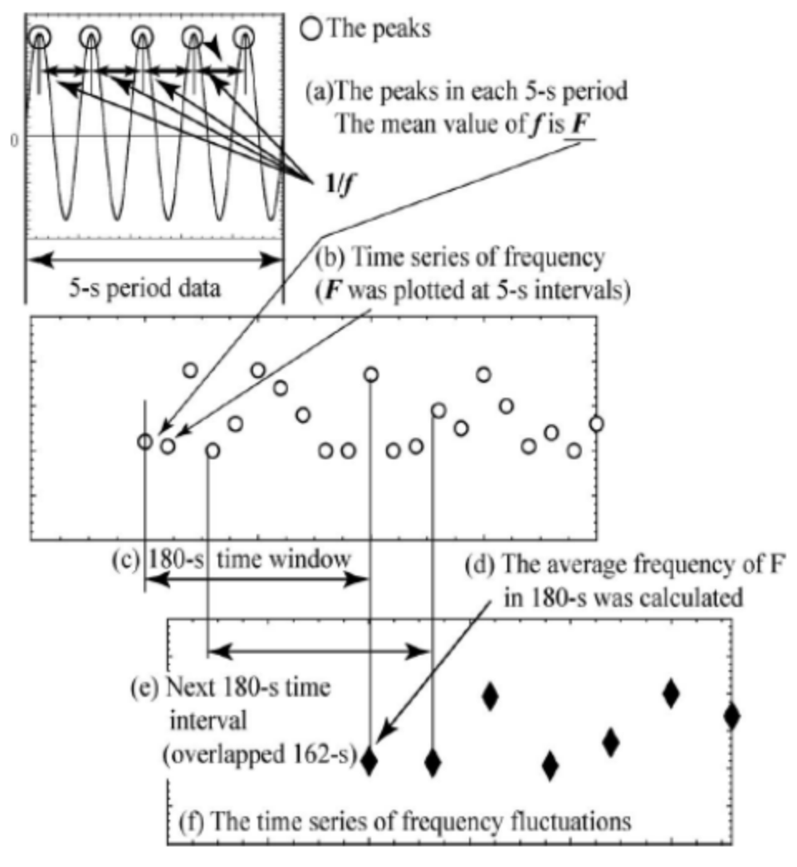

Figure (2) Time series computation of frequency fluctuation

Hardware and software environment for developing an active alcohol driving monitoring system. A mobile phone-based system can operate effectively on its own because mobile phones are highly portable, all the necessary components are already built into them, and their communication services have wide coverage. The minimum requirement for this mobile platform is the presence of simple sensors such as accelerometers, direction sensors, etc. The communication unit and speaker are also good enough for alarm. Behaviors associated with drunk driving are classified into three categories. The first and second categories focus on driving behaviors related to vehicle movement; The third category concerns driving behavior related to driver autonomy and attention.

#### Fuel Economy Impacts of Manual, Conventional Cruise Control, and Predictive Eco-Cruise Control Driving

The paper presents the results of a field experiment that was designed to compare manual driving, conventional cruise control (CCC) driving, and Eco-cruise control (ECC) driving regarding fuel economy. The field experiment was conducted on five test vehicles along a section of Interstate 81 that was comprised of ±4% uphill and downhill grade sections. Using an Onboard Diagnostic II reader, instantaneous fuel consumption rates and other driving parameters were collected with and without the CCC system enabled. The collected data were compared regarding fuel economy, throttle control, and travel time. The results demonstrate that CCC enhances vehicle fuel economy by 3.3 percent on average relative to manual driving, however this difference was not found to be statistically significant at a 5 percent significance level. The results demonstrate that CCC driving is more efficient on downhill versus uphill sections. In addition, the study demonstrates that an ECC system can produce fuel savings ranging between 8 and 16 percent with increases in travel times ranging between 3 and 6 percent. These benefits appear to be largest for heavier vehicles (SUVs).

### The Proposed Solution For Detect Abnormal Drivers Pattern

#### Introduction

In the realm of transportation and road safety, the ability to identify and respond to abnormal driver behavior is of paramount importance. Abnormal driving patterns, encompassing actions such as sudden lane changes, aggressive acceleration, or erratic steering, not only pose risks to the driver but also jeopardize the safety of other road users. To address this critical concern, we present in this section our proposed solution for the detection of abnormal driver patterns.

Our approach is founded on the fusion of cutting-edge technologies, including machine learning algorithms, sensor data from modern vehicles, and real-time monitoring systems. In our pursuit of detecting and analyzing driver patterns, we employed a diverse set of machines learning models, Long Short-Term Memory Networks (LSTM), clustering, neural networks, K-nearest neighbors (KNN), and linear regression. This section presents the findings and outcomes of each method, showcasing their effectiveness in categorizing driving behaviors and providing valuable insights for various applications, from driver safety to traffic management.

#### Generate And Collecting the Data from Simulator.

One alternative way to avoid making people under the effects of alcohol drive real cars which may make a real accident is to collect the data from it by creating a web-based car driving simulator and this is what I did for this study.

This simulator allows me to generate realistic driving scenarios while capturing crucial information about speed, deviation from lanes, and brake usage, which are three key features I used that define driving patterns.

**Speed:**

Speed plays a pivotal role in understanding driving behavior. A web-based car driving simulator enables us to control and measure a driver's speed in various conditions. By adjusting speed limits, we can simulate both normal and abnormal driving patterns. Data on speed provides insights into how drivers respond to different situations.

**Deviation:**

Deviation from the intended lane is another vital aspect of driving patterns. The simulator allows us to simulate real-world lane-keeping scenarios. By monitoring a driver's ability to stay within their lane, we can categorize behaviors or frequent lane changes. This information can be invaluable for developing lane-keeping assistance systems and understanding the impact of road design on driving patterns.

**Brake Usage:**

Effective brake usage is essential for safe driving. A web-based simulator enables us to mimic emergency stops, gradual deceleration, and braking in response to traffic conditions. Analyzing brake usage data helps us assess driver reaction times, brake intensity, and adherence to safe following distances.

**Advantages of Web-Based Simulators:**

Creating a web-based car driving simulator has distinct advantages. It's cost-effective, scalable, and accessible to a wide range of users. Participants can engage in simulated driving from the comfort of their web browsers, eliminating the need for physical setups. Moreover, the simulator allows for controlled experiments in various driving conditions, ensuring data consistency.

**Data Generation and Analysis:**

**Data Collection**

This study leverages an extensive dataset that encapsulates a wide array of driving behaviors, harvested from two distinct sources to ensure robustness and diversity. The primary source of our dataset is derived from a Kaggle competition, consisting of real-world data meticulously collected from phone sensors affixed within vehicles. This rich dataset encompasses a total of **26,075** individual records, contributed by **43** distinct drivers, providing a comprehensive snapshot of everyday driving patterns.

The data obtained from Kaggle contains several critical features that are instrumental in assessing driving behavior:

* **ID**: A unique identifier for each driving session, allowing for individual analysis of driver behavior.
* **Lane**: The lane position of the car, offering insights into lane discipline and changes.
* **Speed**: The vehicle's velocity, which is crucial in understanding the dynamics of driving patterns.
* **Preceding Speed**: The speed of the car directly in front, pertinent for analyzing following distances and speed adaptations.
* **Time Gap**: The time interval between the host car and the preceding vehicle, providing a measure of safety margins maintained by the driver.
* **Road Condition**: Descriptive of the driving environment, whether it be dry, wet, or varied, and its potential impact on driving behavior.
* **Timestamp**: The time at which data points were recorded, enabling the reconstruction of the driving sequence.

**Dataset sample:**

|  |  |  |  |  |  |  |  |
| --- | --- | --- | --- | --- | --- | --- | --- |
| **ID** | **Lane** | **Speed** | **preceding_speed** | **time_gap** | **road_condition** | **label** | **timestamp** |
| **DR_24526** | 1 | 81 | 87 | 94.0 | 1 | 2 | 1332321295 |
| **DR_24526** | 1 | 88 | 81 | 11.0 | 1 | 2 | 1332321307 |
| **DR_24526** | 1 | 88 | 88 | 4.0 | 1 | 2 | 1332321312 |
| **DR_24526** | 2 | 84 | 89 | 127.0 | 1 | 2 | 1332321348 |
| **DR_24526** | 1 | 89 | 88 | 42.0 | 1 | 2 | 1332321354 |
| **DR_24526** | 2 | 91 | 84 | 30.0 | 1 | 2 | 1332321379 |
| **DR_24526** | 2 | 92 | 91 | 4.0 | 1 | 2 | 1332321385 |
| **DR_24526** | 2 | 90 | 92 | 2.0 | 1 | 2 | 1332321388 |
| **DR_24526** | 2 | 92 | 90 | 47.0 | 1 | 2 | 1332321436 |

Graph about featues on different wetherd conditions dry , wet , snow coverd and visible track.

Figure (3) featues on different weather conditions [(kaggel- agg-driving).](https://www.kaggle.com/code/vijaykumar1997/agg-driving)

The second portion of the dataset is a product of a bespoke driving simulator, designed to emulate both standard and erratic driving conditions. This simulation environment generated equal representations for normal and abnormal driving behaviors from a pool of 50 virtual drivers—25 emulating normal behavior and 25 simulating abnormal behavior. The simulator captures the following features:

* **Speed**: The simulated vehicle's speed, reflective of the driver's ability to control velocity under varying scenarios.
* **Deviation**: Lateral deviation from a predetermined path, indicating potential loss of control or correction maneuvers.
* **Brake Pattern**: The application pattern of brakes, which signifies the driver's reactionary measures in response to stimuli.
* **Timestamp**: Similar to the real-world dataset, marking the temporal aspect of the simulated driving data.

**Dataset sample:**

|  |  |  |  |  |  |
| --- | --- | --- | --- | --- | --- |
| **No.** | **Speed** | **Deviation** | **Brake Pattern** | **label** | **timestamp** |
| **1** | 9.6 | 1.82 | 0 | 1 | 1332335129 |
| **2** | 12.6 | 1.78 | 0 | 1 | 1332335133 |
| **3** | 12.8 | 1.85 | 0 | 1 | 1332335168 |
| **4** | 13.0 | 1.96 | 1 | 1 | 1332335193 |
| **5** | 13.1 | 1.60 | 1 | 1 | 1332335351 |
| **6** | 13.9 | 1.12 | 1 | 1 | 1332335369 |
| **7** | 14.5 | 0.85 | 0 | 1 | 1332336613 |
| **8** | 15.6 | 1.50 | 0 | 1 | 1332336648 |
| 9 | 17.1 | 1.69 | 0 | 1 | 1332335129 |

**Data Analysis**

Kaggle Real-World Driving Data

Upon acquisition, the Kaggle dataset underwent a rigorous preprocessing routine. Each record was scrutinized for completeness and integrity, ensuring no sensor errors or missing values could skew the results. Given the real-world nature of this data, it was paramount to handle outliers judiciously—striking a balance between data authenticity and analytical clarity.

The dataset’s vastness and variety offer an empirical foundation for understanding real-world driving behaviors. Statistical analyses were conducted to uncover patterns and correlations within the data. For instance, speed variances were cross-referenced with road conditions to assess how environmental factors influence driving habits.

The analysis also entailed a temporal examination, where sequences of driving data were reconstructed using timestamps. This sequence reconstruction facilitated the study of behavior over time, allowing for the assessment of driver reactions to the evolving road environment and traffic conditions.

Simulator-Generated Driving Data

The simulator-generated data serves as a controlled complement to the real-world data, providing clear-cut cases of normal and abnormal driving for algorithm training and validation. To mirror the complexity of real-life driving, the simulation was calibrated to replicate various traffic scenarios, weather conditions, and road types.

Initial analyses focused on contrasting normal versus abnormal driving patterns. Speed and deviation were particularly telling, with abnormal driving often characterized by higher speed variance and increased deviation. Brake pattern analysis provided further granularity, as erratic braking often correlates with abnormal driving behavior.

The simulated data was methodically timestamped to enable detailed temporal analysis, much like the Kaggle dataset. The intention was to not only capture instantaneous actions but also to understand the lead-up and aftermath of driving decisions.

Combined Dataset Insights

The fusion of real-world and simulated datasets presents a unique opportunity to validate the model's applicability across different data realms. The combined dataset is subjected to a comprehensive exploratory data analysis, ensuring a multifaceted understanding of driving behaviors. This amalgamation enriches the dataset, allowing the resulting models to be well-rounded and adaptive to both actual and simulated driving conditions.

By analyzing these diverse data sources collectively, the study gains a nuanced view of driving patterns, transcending the limitations of any single-source dataset. The resultant models, informed by such an all-encompassing dataset, are expected to demonstrate elevated levels of accuracy and generalizability when deployed in real-world scenarios.

As participants use the web-based simulator, data on speed, deviation, and brake usage are collected in real-time. This data I can use this to train my models and generate patterns for normal and abnormal driving with high accuracy this is a sample of data structure I export from my simulator:

**[**[1.84,24.8,0],[2.56,24.5,0],[3.18,24.2,0],[1.34,23.8,0],[1.07,23.5,0],[0.98,23.2,0],[0.52,22.9,0],[0.49,22.6,0],[0.74,22.3,0],[1.02,22,0],[1.16,21.8,0],[0.69,21.5,0],[0.87,21.2,0],[1.23,21.2,0],[1.23,21,0],[1.32,18.8,0],[1.23,18.9,0]**]**

Is an array of arrays each array has three values **[deviation, speed, brake pattern, timestamp].**

**Some of Figures for Simulator:**

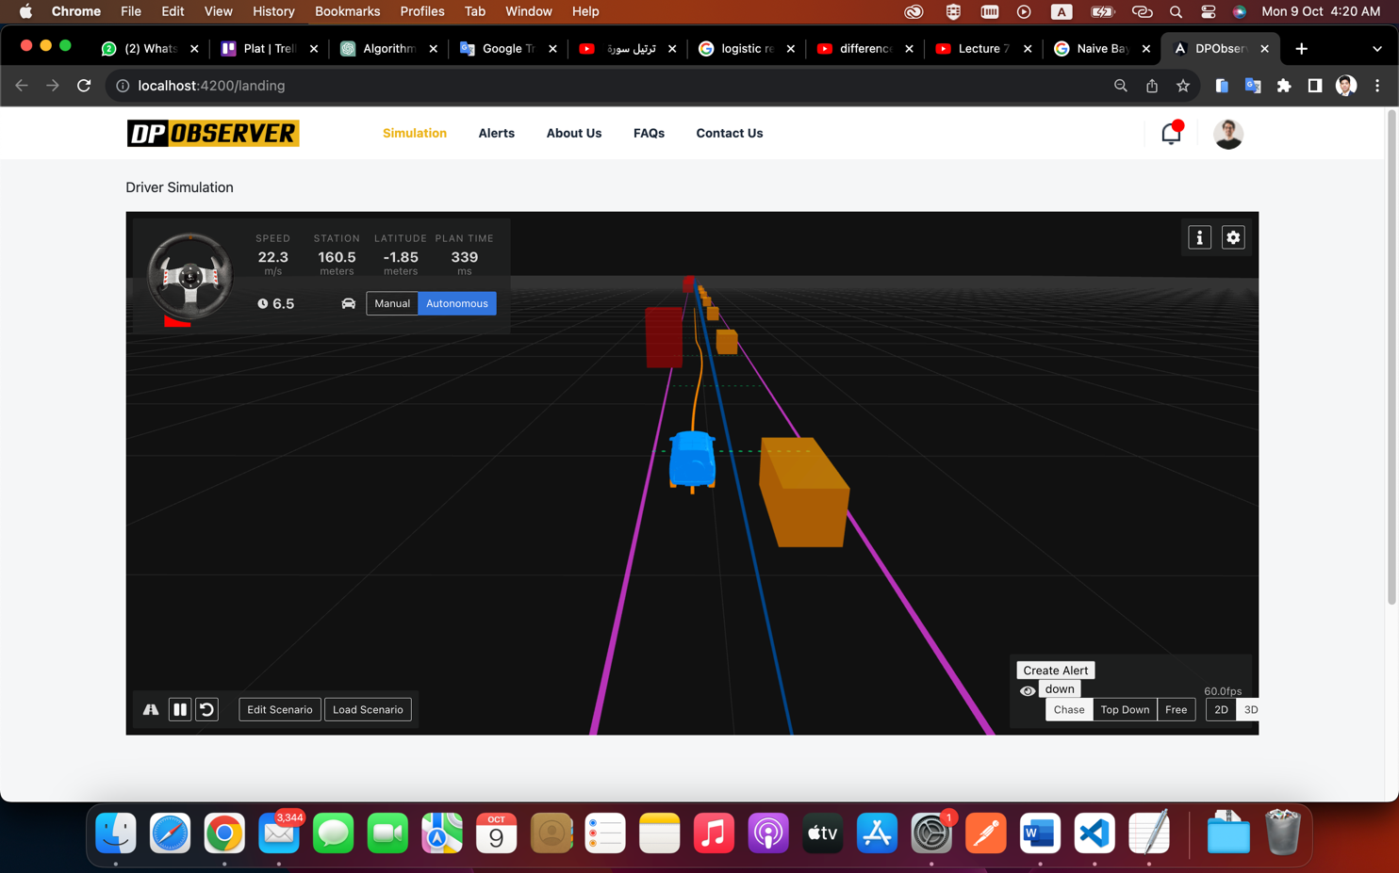

Figure (**3**) Car Simulator I get all information’s from road

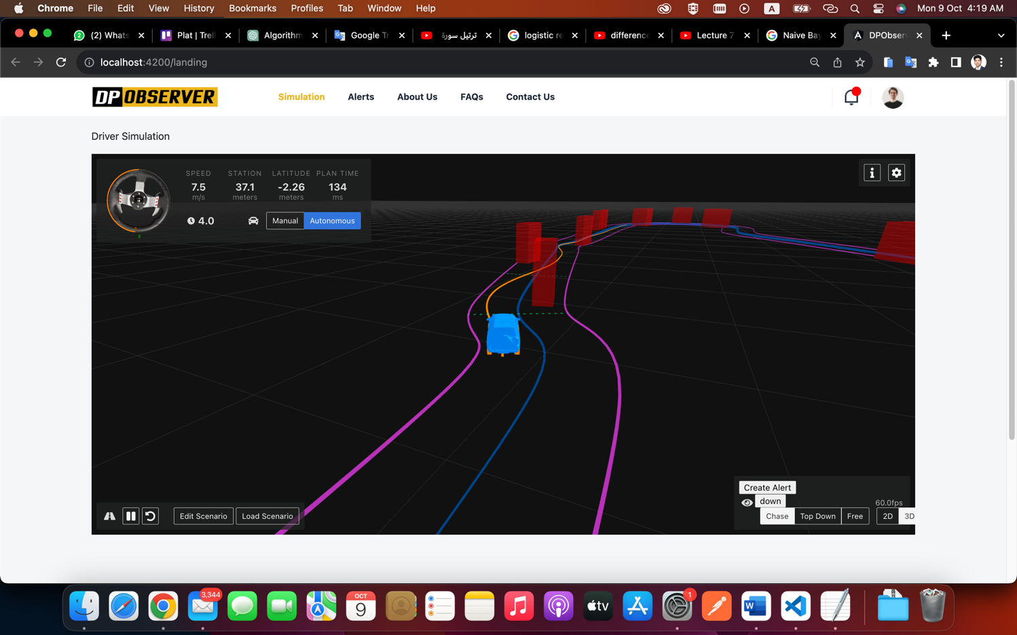

Figure (4) Car Simulator II

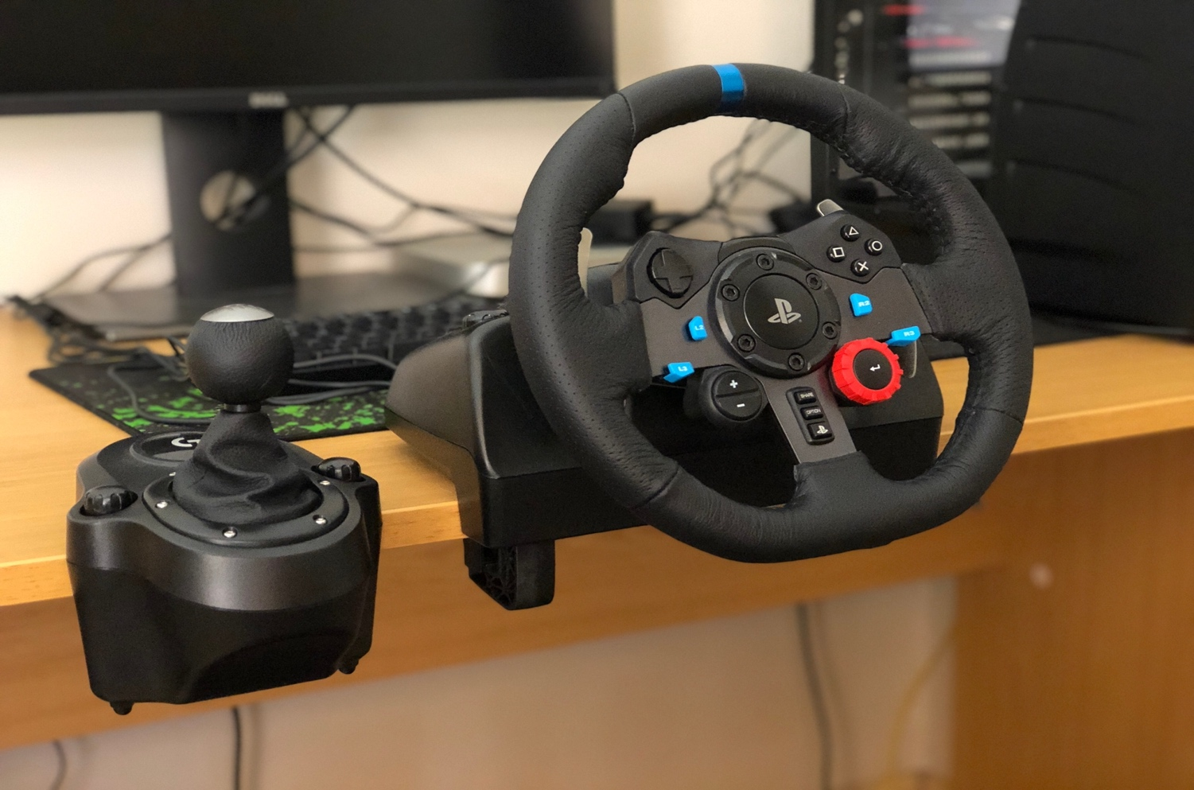

Figure (5) Real Car wheel Connected To Web Simulator

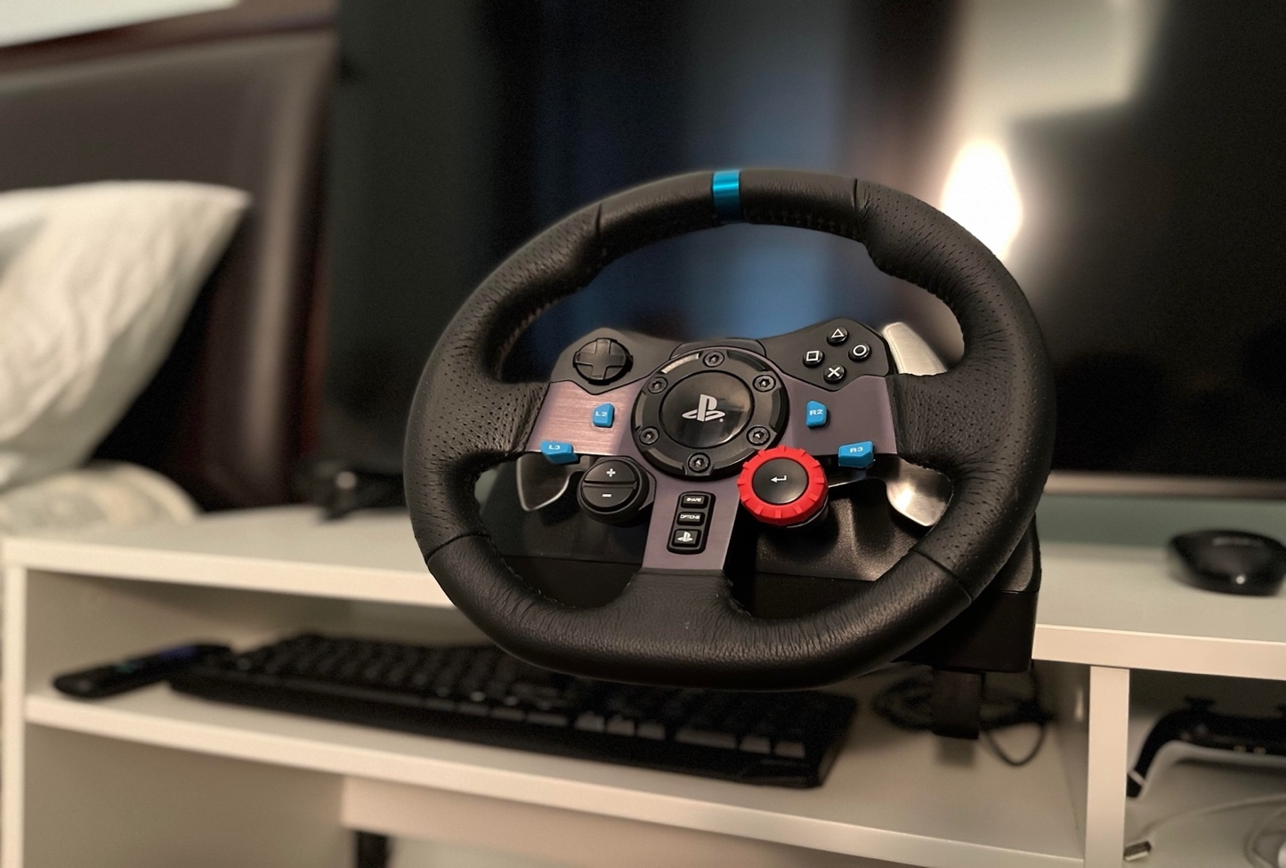

Figure (6) Real Car wheel Connected To Web Simulator

#### Chose Algorithm to Build An AI Model.

after we get data from real dataset (kaggel) and create the simulator and generate data with a specific structure next step is to select the best model that can give us the highest accuracy depending on the nature of my data, we can start this process in three steps:

1. define the models and their algorithms that we can use in this case.
2. training the models then test and evaluate the accuracy of each of them.
3. choose one of them to implement on my solution (**DPObserver**).

With these steps, we can create a comparison between each algorithm and build good software solutions have the ability to detect abnormal patterns and make a decision to prevent any accident from properly happening and this is the main goal of my study.

##### **Define Different Algorithms:**

1. **Long Short-Term Memory Networks (LSTMs):**

Long Short-Term Memory networks are a specialized form of recurrent neural networks capable of learning long-term dependencies in sequential data. LSTMs are distinguished by their use of gate mechanisms that regulate the flow of information. These gates—namely, the input, forget, and output gates—allow LSTMs to selectively remember patterns over long sequences without the risk of vanishing or exploding gradients. This makes them highly suitable for complex sequential tasks such as time series prediction, natural language processing, and speech recognition. In the context of driving behavior analysis, LSTMs can effectively capture temporal dynamics and dependencies that characterize typical or anomalous driving patterns.

1. **Bidirectional Long Short-Term Memory Networks (BiLSTMs):**

Bidirectional LSTMs extend the conventional LSTM architecture by processing data in both forward and backward directions. This bidirectionality enables the networks to have both backward and forward information about the sequence at every time step. BiLSTMs are particularly useful in scenarios where the context of the entire sequence is crucial for making accurate predictions. In driving behavior analysis, BiLSTMs can provide a more nuanced understanding by considering sequences of actions leading up to and following a particular event.

1. **Gated Recurrent Units (GRUs):**

Gated Recurrent Units simplify the LSTM architecture by combining the forget and input gates into a single "update gate" and merging the cell state and hidden state. Despite their simplified structure, GRUs can match the performance of LSTMs on many tasks while being computationally more efficient. They are particularly effective in scenarios where the dataset size is relatively small, or the temporal dependencies are not excessively long. For driving behavior, GRUs can discern patterns and anomalies in driving sequences, often with faster training times compared to LSTMs.

1. **1D Convolutional Neural Networks (1D_CNNs):**

1D Convolutional Neural Networks are typically utilized in the analysis of one-dimensional signal data. They are adept at extracting high-level features by applying filters to the sequence data, capturing local dependencies and translational invariances. This makes 1D_CNNs especially effective for tasks like audio analysis and time series classification, where the presence of certain patterns or anomalies is more significant than the exact position within the sequence. In analyzing driving data, 1D_CNNs can identify critical features such as abrupt accelerations or decelerations, which are indicative of driving behaviors.

1. **Simple Recurrent Neural Networks (SimpleRNNs):**

SimpleRNNs are the most basic form of recurrent neural networks, wherein connections between units form a directed cycle. This fundamental structure enables them to use their internal state (memory) to process sequences of inputs. However, they are less capable of handling long-term dependencies due to issues like vanishing gradients. Despite this, SimpleRNNs can serve as a baseline for more complex models and are computationally efficient, making them a quick and straightforward solution for preliminary sequence learning.

1. **Deeper 1D Convolutional Neural Networks (Deeper_1D_CNN_Adjusted):**

#### Deeper 1D Convolutional Neural Networks build on the basic 1D_CNN architecture by incorporating multiple convolutional and pooling layers. This depth allows the network to learn more complex and abstract features from the data, with each subsequent layer building on the features identified by the previous one. The added complexity can often result in improved model performance, particularly for complex sequential patterns in large datasets. When applied to driving behavior analysis, deeper 1D_CNNs can distinguish between nuanced behaviors and different driving conditions, learning from the intricate patterns within the data.

##### **3.3.2 Test and Evaluate Each One**

After collecting data and build small project depend on Python and flask framework this diagram for models training process:

Input dataset.

Training set (80% of data)

Test set (20% of data)

Fit() the model based on the input of sample data and then predict() training data

LSTM

BiLSTM

1D_CNN

SimpleRNN

Deeper_1D_CNN_Adjusted

GRU

training machine learning predictive models (Individual for each classifier)

Predict unseen test data and calculate accuracy (in %)

Visualizing output

Figure (13) Models Training Process

This is 3D figure shows how right and wrong data **Individually** present in 3 dimensions each dimension representing a feature from 3 Deviation – Speed – Break.

Figure (14) Right Data

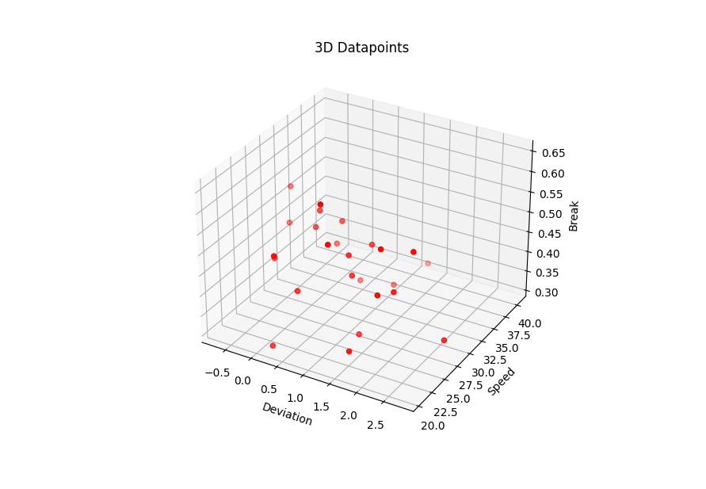

Figure (15) Wrong Data

This is 3D figure shows 3 dimensions else but in this case all data mixed in one Graph.

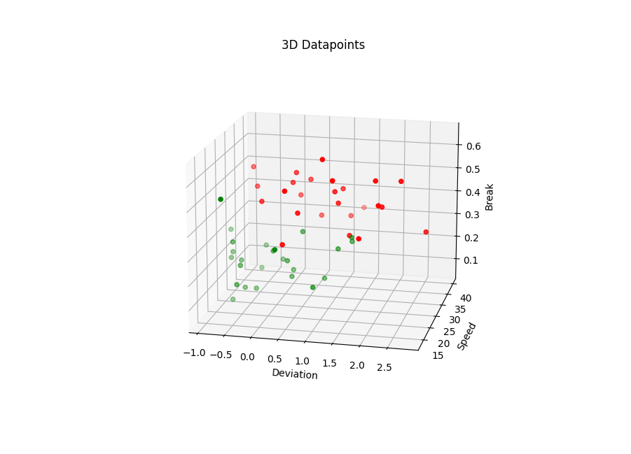

Figure (16) All Data in Graph in 3 dimensions

This is a 3D Figures show us wrong and right data individually after cleaning data and add label to each group (right, wrong) to test models and export the accuracy (in %) you can see it in next table (3-1).

We extract accuracy from each algorithm individually many times each time try to get high accuracy by cleaning data and avoiding overfitting until get the results that you can find in the table below:

**notes** “Accuracy can be better if we add more test data.”

**The accuracy for real dataset (kaggel):**

|  |  |  |  |
| --- | --- | --- | --- |
| **No.** | **Algorithm** | **Data length** | **Accuracy** |
| 1 | LSTM Algorithm | 24073 | 77.97% |
| 2 | BiLSTM Algorithm | 24073 | 84.10% |
| 3 | GRU Algorithm | 24073 | 77.36% |
| 4 | 1D_CNN Algorithm | 24073 | 78.51% |
| 5 | SimpleRNN Algorithm | 24073 | 77.58% |
| 6 | Deeper_1D_CNN_Adjusted Algorithm | 24073 | 76.49% |

Table (1): Comparison between Different Machine Learning Models - real dataset.

**The accuracy for simulator dataset (DPObserver):**

|  |  |  |  |
| --- | --- | --- | --- |
| **No.** | **Algorithm** | **Data length** | **Accuracy** |
| 1 | LSTM Algorithm | 50 | 88.02% |
| 2 | BiLSTM Algorithm | 50 | 89.39% |
| 3 | GRU Algorithm | 50 | 87.45% |
| 4 | 1D_CNN Algorithm | 50 | 82.36% |
| 5 | SimpleRNN Algorithm | 50 | 84.58% |
| 6 | Deeper_1D_CNN_Adjusted Algorithm | 50 | 75.55% |

Table (1): Comparison between Different Machine Learning Models

##### **3.3.3 Chose Most Effective and Applicable Algorithm**

Depend on previous table (3-1) the most affection model is LSTM, GRU, BiLSTM, 1D CNN, SimpleRNN, and a deeper 1D CNN so I decide to choose **BiLSTM** , **LSTM** and **GRU** to build model in my solution because of fits with my data type .

#### Design Solution Architecture:

Join us on this journey as we navigate the practical aspects of transforming a visionary architectural design into a tangible software solution. The implementation of our solution architecture marks a critical milestone in our mission to enhance road safety, optimize traffic management, and contribute to the evolution of intelligent transportation systems.

In the following sections, we will provide insights into the technologies, methodologies, and diagrams that underpin our software's implementation, with the ultimate aim of unraveling the intricate patterns of driver behavior using the power of artificial intelligence.

##### **Context diagram:**

This is a context diagram to clarify the level of my solution architecture it starts with an agent in our case is car sensor that sends the data to my solution DPObserver after analysis after that he sends an alert to the police station if the case is dangerous.

Figure (17) Context diagram

##### **3.4.2 Component diagram:**

Now I demonstrate the main components of my solution “DPObserver”, it starts with the first entity car agent pulls notifications from cloud servers connected with the backend that has a link with AI model service and database component,

It gives the last component (police incident) report or alert in some cases the system makes a decision on it.

Figure (18) Component diagram

### Components Architecture Description:

**Car Agent:** This is the vehicle's interface, equipped with various sensors that collect real-time data on driving patterns. It can be thought of as a mobile data acquisition unit that captures key metrics related to vehicle operation and driver behavior.

**Data Collector**: The data from the Car Agent is sent to the Data Collector, which acts as a repository and preprocessing center. This module aggregates data performs initial cleaning, and structures it into a suitable format for analysis. It serves as a staging area for raw driving data before further processing.

**Behavior Decision Engine**: After initial preprocessing, the data is passed to the Behavior Decision Engine. This crucial component analyzes the incoming data streams to make real-time decisions. It is responsible for identifying potential instances of abnormal driving behavior that may warrant further investigation or immediate action.

AI Model: The heart of the analytical process lies within the AI Model. Here, advanced machine learning algorithms, possibly including LSTM networks for sequence analysis, are trained on historical data to recognize patterns indicative of abnormal driving. The AI Model receives input from the Behavior Decision Engine for both ongoing pattern detection and continuous model improvement through retraining with new data.

**Alert Server**: Upon detection of a possible abnormal event by the AI Model, an alert is generated and sent to the Alert Server. The server manages these alerts and determines the appropriate response protocols to enact.

**Car Agent (Pull Notification):** If an alert corresponds to an immediate risk, a notification is pushed to the Car Agent, which in turn may alert the driver to take corrective action. This real-time feedback loop is vital for preventing potential accidents or mitigating hazardous situations.

**Place Incident System:** Concurrently, the Alert Server communicates with external systems, such as a Police Incident System. Here, alerts can be evaluated by traffic management personnel, and if necessary, dispatched to law enforcement or emergency services. This link ensures that incidents are recorded and appropriate law enforcement measures can be taken, enhancing road safety at a broader level.

**Report Incident (Alert):** This represents the flow of information from the Alert Server to the Place Incident System. It signifies the reporting mechanism that conveys detected incidents to the authorities.

### Overall Workflow

* The Car Agent captures data from the vehicle's sensors and relays it to the Data Collector.
* The Data Collector processes and sends the data to the Behavior Decision Engine.
* The Behavior Decision Engine evaluates the data and interfaces with the AI Model for pattern detection.
* Upon detection of an abnormal pattern, the AI Model signals back to the Behavior Decision Engine.
* The Behavior Decision Engine then prompts the Alert Server to act.
* The Alert Server issues a pull notification to the Car Agent to alert the driver and simultaneously reports the incident to the Police Incident System.

### Conclusion

The DPobserver solution architecture is a sophisticated, closed-loop system designed for real-time surveillance and intervention of abnormal driving patterns. By integrating in-vehicle sensor data with advanced AI analytics and real-time alerting mechanisms, DPobserver aims to contribute significantly to enhancing road safety, reducing the incidence of traffic accidents, and streamlining traffic incident management and response.

##### **3.4.3 Technology diagram:**

I used many technologies in this solution and integrate using REST API in the best way to get high value from it and this a list:

1. Front-end: Angular framework
2. Backend: NodeJS
3. AI Model: Flask, sklearn and Panda’s lib
4. Database: NoSQL (MongoDB).
5. Realtime: Firebase (cloud service)

Front-end layer (Angular V 15.1)

AI Model Env layer (flask V 2.3.3)

Back-end layer (NodeJS V 18.17.1)

DATA BASE

layer

(No SQL - MongoDB)

Figure (19) Technologies diagram

##### 

##### **3.4.4 Sequence diagram:**

Now this sequence demonstrates the actions happened in system:

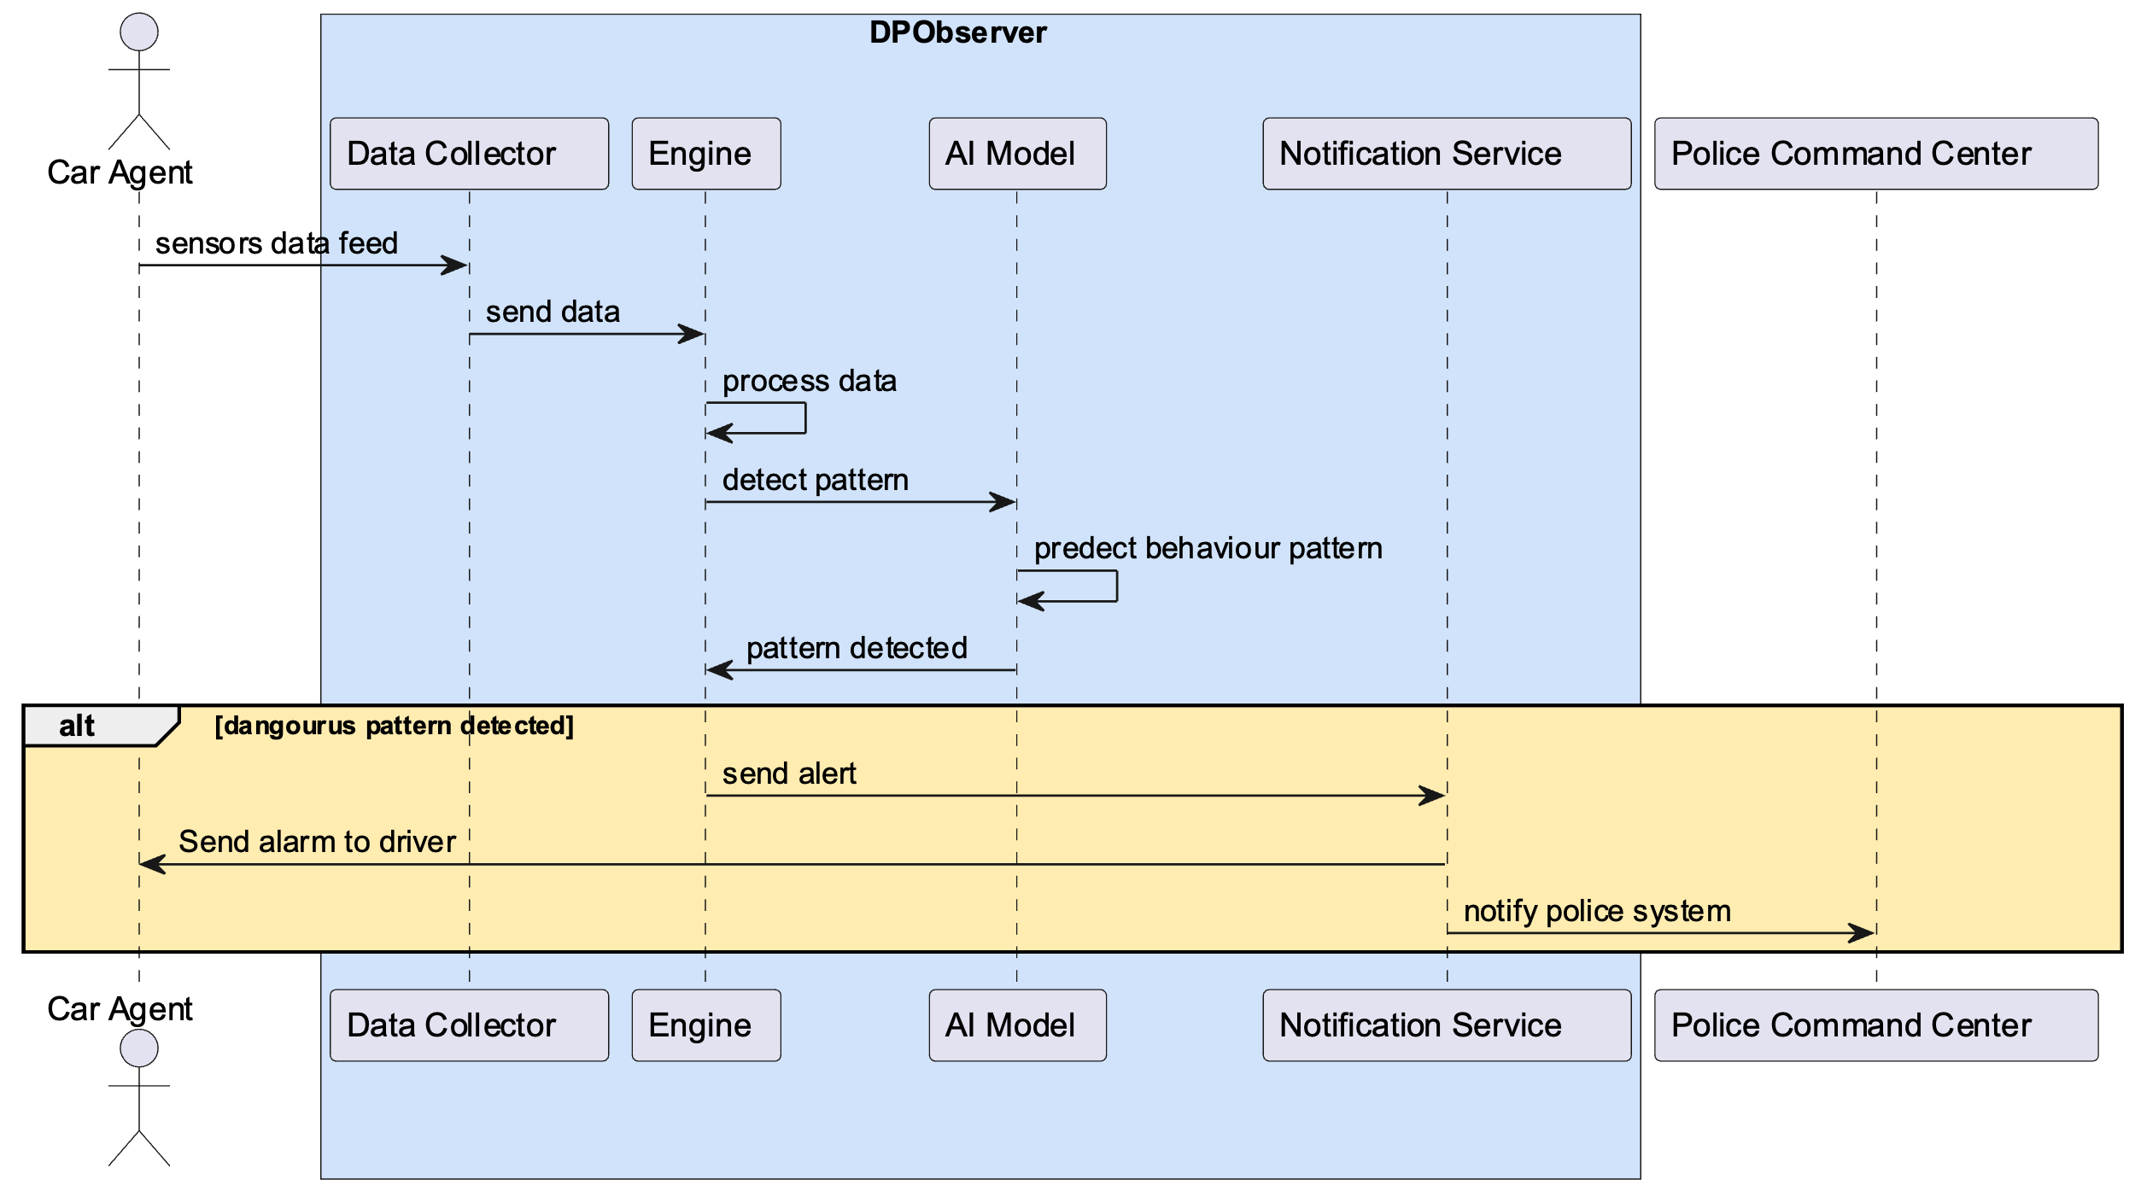

Figure (20) Sequence diagram

### Description :

The sequence diagram outlines an automated system, termed "DPObserver," for detecting and responding to abnormal driving patterns. The system involves multiple components interacting in real-time, which are described below:

1. **Car Agent**: This represents an interface or a proxy within a vehicle through which sensor data is collected. It could be part of a telematics system or an app on the driver's smartphone.
2. **Data Collector**: The first step in the process begins with the "Car Agent" feeding sensor data to the "Data Collector." This component is responsible for gathering various inputs such as speed, acceleration, GPS location, and possibly other telemetry data indicative of driver behavior.
3. **Engine**: Upon receiving the data, the "Engine" processes it for analysis. This involves cleaning, normalizing, and preparing the data for pattern detection, which may include extracting features relevant to driving behavior.
4. **AI Model**: The processed data is then forwarded to the "AI Model," where the core analysis takes place. The AI Model, equipped with machine learning capabilities, likely a Long Short-Term Memory (LSTM) network, evaluates the data to predict behavior patterns. The LSTM's ability to analyze sequences makes it adept at recognizing complex driving patterns over time.
5. **Pattern Detection**: The AI Model performs continuous analysis, predicting behavior patterns as new data arrives. When a pattern indicative of abnormal or dangerous driving is detected, the model signals this finding back to the Engine.
6. **Notification Service**: In response to a dangerous pattern being detected, the Engine communicates with the "Notification Service."
7. **Alert System**: The "Notification Service" then takes two concurrent actions:
   * It sends an alert back to the "Car Agent," which could trigger an alarm or warning to the driver, allowing for immediate corrective action.
   * It also notifies an external system, designated as the "Police Command Center," possibly to inform authorities about the potential danger or to take further preventive measures.

### Conditional Alert (alt) Pathway:

* The sequence diagram includes an alternate pathway (highlighted with **alt**), representing the conditional logic where alerts are issued only if a dangerous pattern is detected.
* This condition reflects a system designed to minimize unnecessary notifications, ensuring that only significant events trigger the alert process.

### Conclusion:

The DPObserver system depicted in the sequence diagram represents a sophisticated, real-time monitoring solution designed to enhance road safety. By integrating advanced AI analytics with a responsive alert mechanism, the system aims to provide an immediate warning about abnormal driving behaviors, contributing to proactive accident prevention and enhancing the overall safety of road travel. This system exemplifies the potential of AI and machine learning to provide actionable insights in critical real-world applications.

##### **3.4.5 Solution Code:**

I have implemented for two approaches the real data and I use LSTM algorithm for sequential data and the second one use different algorithms such as Cluster, Naive bayes, support vector machine etc., to get high accuracy let’s start with LSTM algorithm:

**Real Data:**

In this section, we describe the implementation of a machine learning approach using Long Short-Term Memory (LSTM) networks designed to differentiate between normal and abnormal driving patterns. The LSTM algorithm is particularly suitable for this task due to its ability to process entire sequences of data and recognize patterns over time, which is essential in understanding the dynamics of driving behavior.

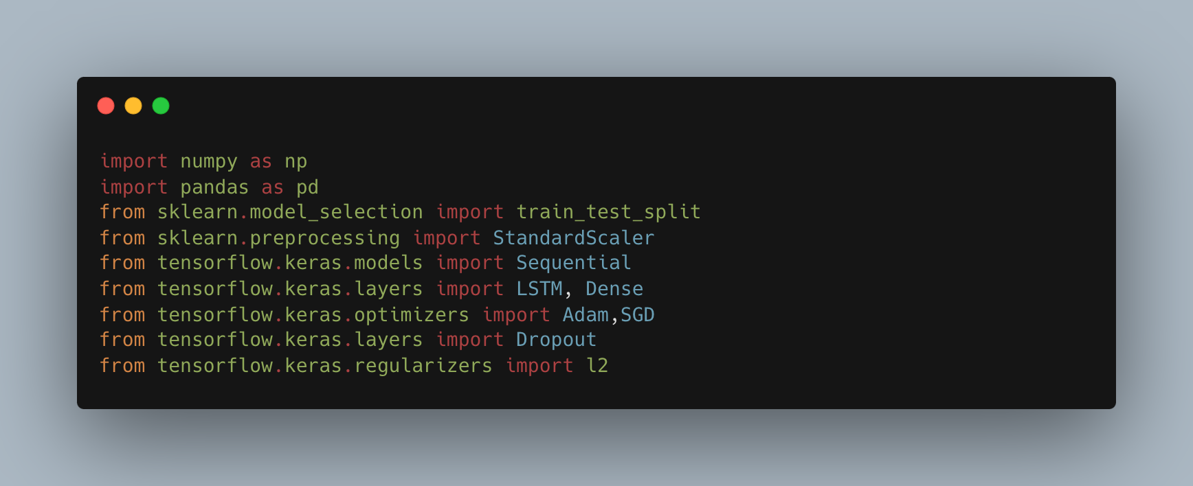

Figure (18) Code of the implementation – import libs we need.

I start in first step to import all library I need for implementation.

* We begin by importing numpy and pandas, foundational libraries for numerical computing and data manipulation. numpy allows us to work efficiently with arrays, while pandas provides the functionality to handle data structures such as DataFrames, which are instrumental in storing and manipulating tabular data.
* The train_test_split function from the scikit-learn library is employed to segregate our data into training and validation sets. This segregation is critical for assessing the model's ability to generalize to unseen data, which simulates real-world application conditions.
* Next, the StandardScaler module is incorporated to standardize our dataset, a preprocessing step that normalizes feature values to have a mean of zero and a standard deviation of one. This normalization is pivotal for LSTM models as it ensures that all input features contribute equally to the model's learning phase.
* Using TensorFlow's Keras API, we instantiate a Sequential model, which provides a linear stack of neural network layers. The Sequential model is a suitable choice for a clear and straightforward construction of LSTM architectures.
* The LSTM layer is integral to our architecture as it specializes in processing sequences and capturing temporal dependencies, an attribute that is particularly beneficial for modeling driving patterns over time. Following the LSTM layer(s), Dense layers are added to act as output layers for the network, translating the LSTM outputs into a final prediction.
* Optimization algorithms like Adam and Stochastic Gradient Descent (SGD) are considered for model training. Adam is renowned for its adaptive learning rate capabilities, which could lead to faster convergence during training. On the other hand, SGD is a more traditional approach, sometimes favored for its simplicity and proven effectiveness over numerous applications.
* Dropout is included as a layer within our model to introduce regularization. By randomly setting a fraction of the input units to zero at each update during training, dropout prevents overfitting, ensuring that our model maintains robustness and improves its predictive power.
* L2 regularization is another measure to combat overfitting, penalizing large weights in the learning process by adding a regularization term to the loss function. This term is proportional to the square of the magnitude of the coefficients, which encourages the network to maintain smaller weights, leading to simpler models.

The combination of these modules and techniques sets the foundation for constructing a machine learning model capable of learning from the intricacies of driving data. The goal is to build a model that not only learns from the historical data but also generalizes well to new, unseen scenarios, ultimately providing a reliable system for the detection of abnormal driving patterns.

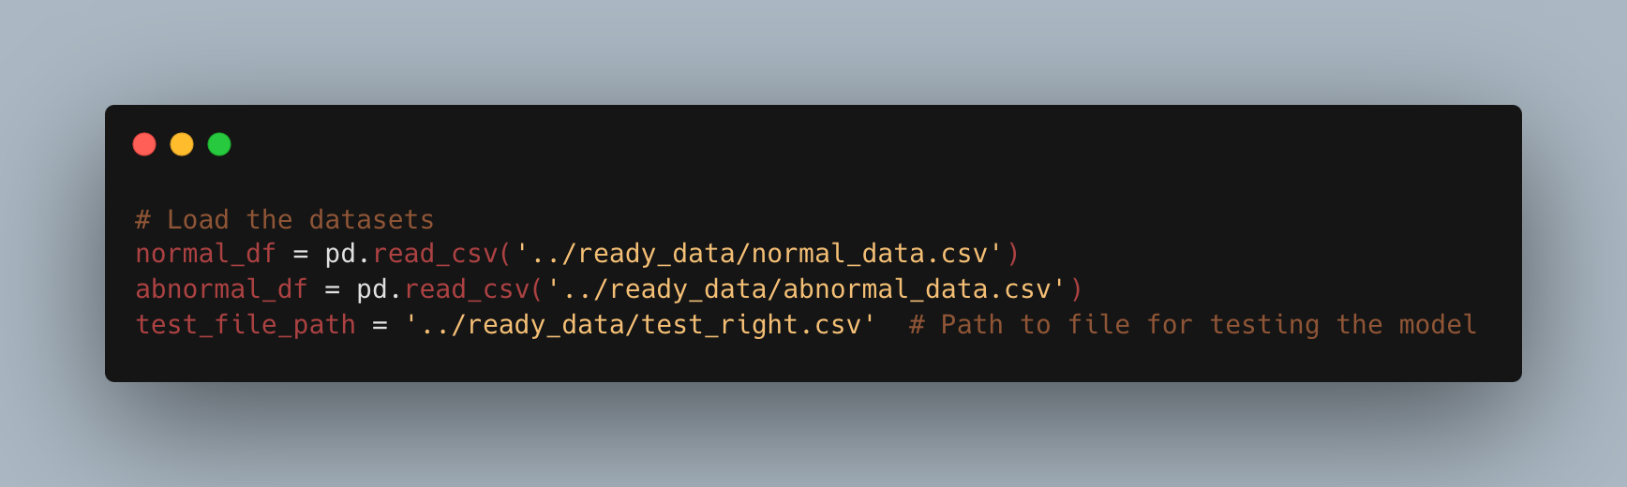

Figure (20) Code of the implementation – read files.

**Loading and Integrating the Datasets:**

Here, we are loading two separate datasets: one that contains examples of normal driving patterns and another that comprises instances of abnormal driving behavior. These datasets are fundamental to our study as they embody the ground truth against which the LSTM model will learn and subsequently make predictions. The pd.read_csv function is called upon to read the CSV files and convert them into Pandas DataFrames. These DataFrames (normal_df and abnormal_df) provide a convenient and powerful data structure for subsequent data manipulation and analysis.

The normal_data.csv file is expected to have a collection of driving data that has been labeled as normal, representing standard, safe driving behavior under usual conditions. Conversely, the abnormal_data.csv file consists of driving data that has been identified as abnormal, possibly containing patterns that signify dangerous or erratic driving, such as sudden stops, excessive speeding, or irregular turns that could indicate an increased risk of accidents.

The test_file_path is a variable assigned to the path of a CSV file reserved for testing the model. This testing dataset is crucial for objectively evaluating the model's performance. It is imperative that the data in test_right.csv has not been used in the training process to ensure that the evaluation of the model's generalization capabilities is unbiased and valid.

The separation of data into training, validation, and testing sets mirrors the rigor and structure required in empirical research, enabling us to draw reliable conclusions about the model's effectiveness in real-world application scenarios.

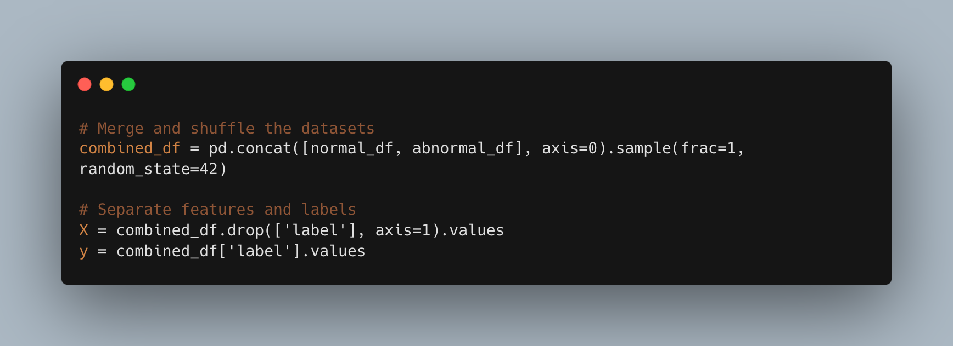

Figure (21) Code of the implementation – separate the features.

**Merging and Shuffling the Datasets:**

This line combines the data from normal_df and abnormal_df into a single DataFrame, combined_df. The pd.concat() function concatenates the two DataFrames along the rows (as indicated by axis=0). Following the concatenation, .sample(frac=1, random_state=42) is used to shuffle the data. The frac=1 parameter indicates that we sample 100% of the data (thus, shuffling the entire set), and random_state=42 seeds the random number generator for reproducibility, ensuring that our results can be consistently reproduced.

**Separating Features and Labels:**

In the context of supervised learning, which is the domain of this research, we must separate the features (independent variables) from the labels (dependent variables or the target variable). The features, stored in X, represent the input data that the model will use to learn the patterns associated with driving behaviors. The .drop() method removes the 'label' column from the combined DataFrame, which contains the classification of each pattern as normal or abnormal, while .values converts the remaining DataFrame into a NumPy array suitable for model input.

The labels, stored in y, represent the ground truth that the model aims to predict whether a given pattern is normal (0) or abnormal (1). The extraction of y simply involves accessing the 'label' column of the combined_df and converting it into a NumPy array.

The distinction between X and y is a crucial aspect of the training process, where X will be used to train the model, and y will enable the LSTM network to learn the correct classification, refining its weights through backpropagation and the optimization process.

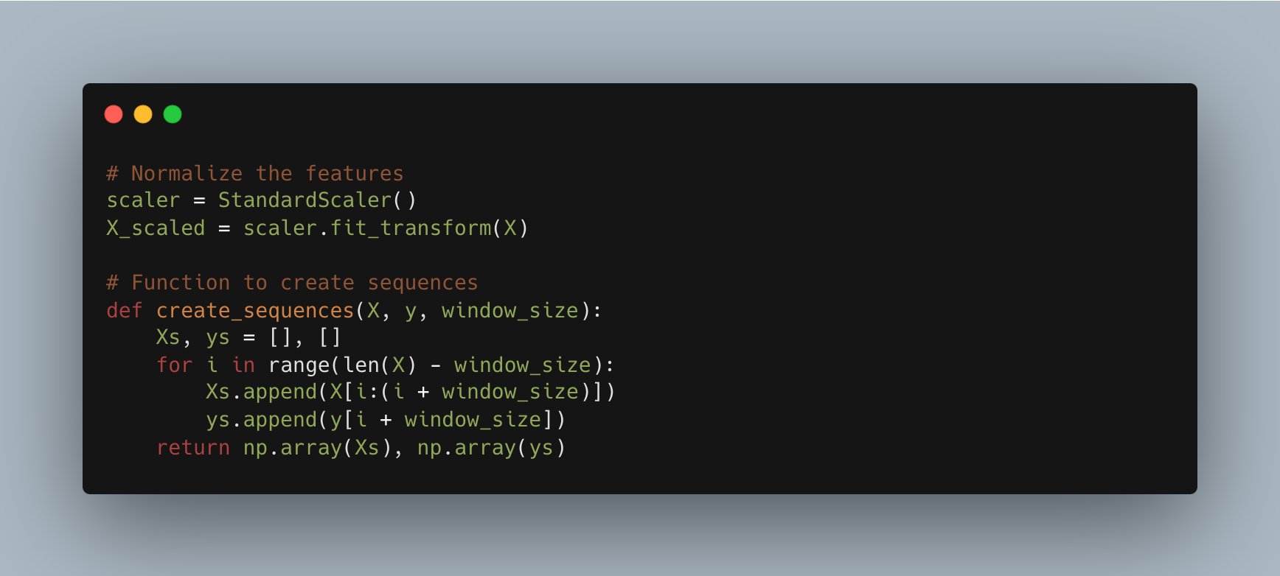

Figure (22) Code of the implementation – Feature normalization and sequence creation.

**Feature Normalization:**

Here we initialize a StandardScaler object and apply it to our feature set X. The fit_transform() method computes the mean and standard deviation of each feature, then scales them such that they have a mean of zero and a standard deviation of one. This process, known as feature scaling or normalization, is crucial for LSTM models because they are sensitive to the scale of input data. Normalized data help ensure that the LSTM model's learning process is efficient and that it does not bias towards features with inherently larger scales.

**Sequence Creation for LSTM:**

This function is a pivotal part of the code for processing time-series data suitable for LSTM analysis. LSTM networks require input data in the form of sequences to capture temporal dependencies. The create_sequences function constructs these sequences from our normalized feature set X_scaled.

* Xs and ys are initialized as empty lists that will be populated with sequences of features and their corresponding labels.
* The for loop iterates over the normalized features X, creating overlapping windows of data of length window_size. Each window of feature data (X[i:(i + window_size)]) is appended to the list Xs, and the corresponding label (y[i + window_size]) is appended to the list ys.
* The function returns Xs and ys as NumPy arrays, now formatted correctly for training the LSTM model. Each element of Xs is a sequence of window_size consecutive data points from X, and each element of ys is the label predicting the outcome of the sequence.

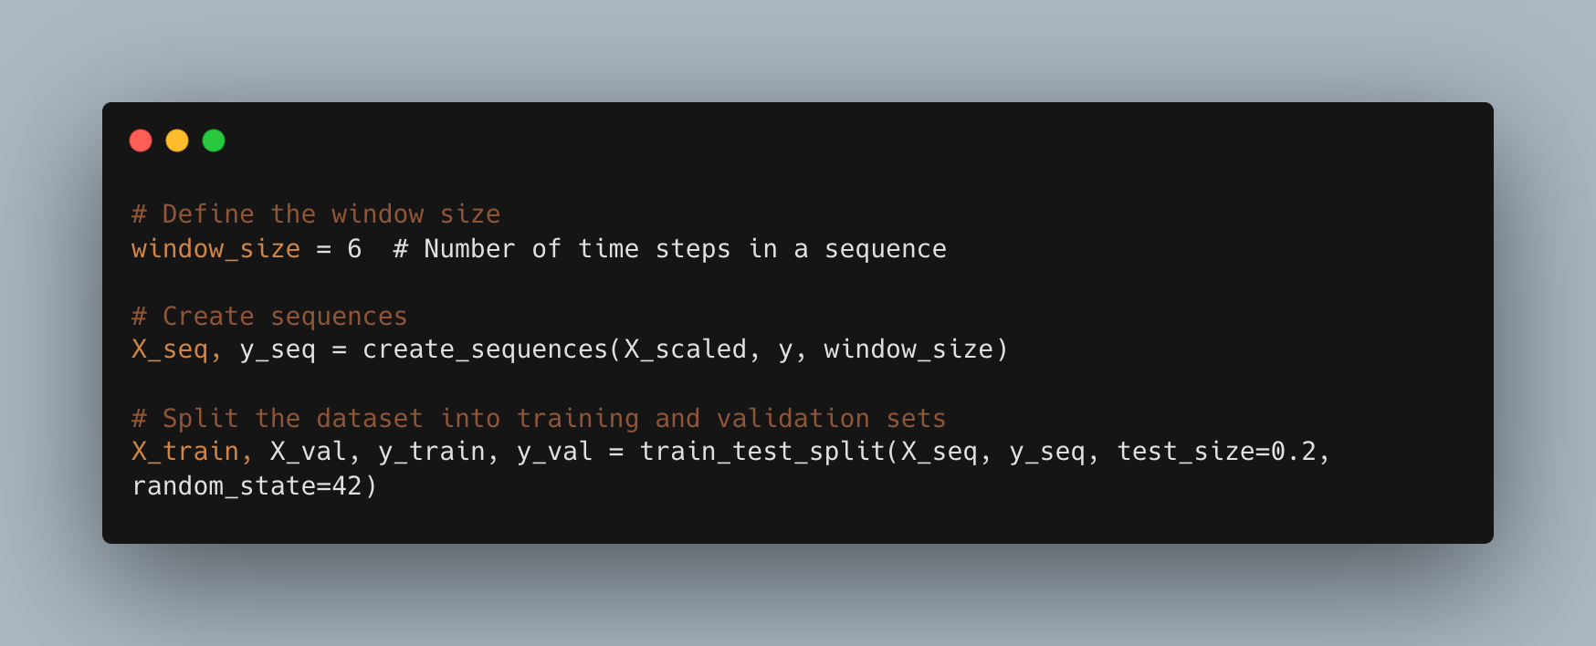

Figure (22) Code of the implementation – Data preparation.

**Setting the Sequence Window Size:**

The window_size variable defines the number of consecutive time steps to consider in each input sequence for the LSTM model. Here, a size of 6 is chosen, meaning that each input sequence will consist of data from 6 consecutive time points. This hyperparameter is crucial as it determines how much temporal context the model will consider when learning to identify patterns. The selection of 6 as the window size suggests that patterns spanning this duration in the dataset are significant for the classification task at hand.

**Creating Sequences from the Normalized Data:**

Using the create_sequences function defined previously, we apply the window size to our scaled feature set X_scaled. The function generates new arrays X_seq and y_seq, where X_seq contains sequences of features ready for input into the LSTM, and y_seq contains the corresponding labels for each sequence. This transformation is critical for sequence-based models like LSTM, as it allows the network to learn from the temporal order and dependencies within the data.

**Splitting the Data for Training and Validation:**

Here, the train_test_split function is used to partition the sequences into a training set (X_train, y_train) and a validation set (X_val, y_val). The test_size=0.2 parameter reserves 20% of the data for validation, meaning that 80% is retained for training the model. This separation allows the LSTM to learn from the training data while enabling us to evaluate its performance on unseen validation data, simulating real-world performance. The random_state=42 ensures that the split is reproducible; anyone running the code with this seed will get the exact same split, which is essential for replicable research findings.

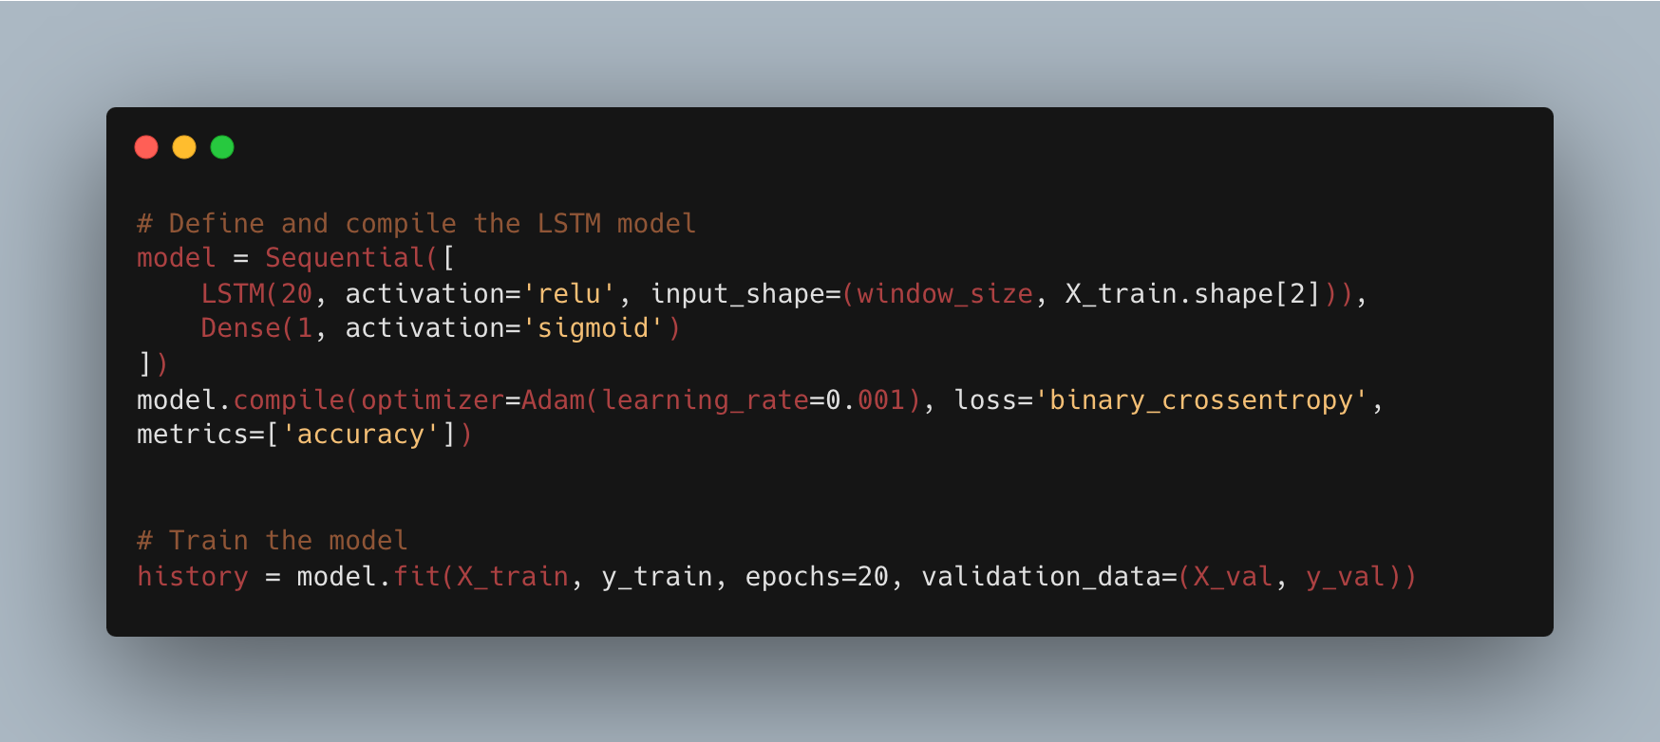

Figure (23) Code of the implementation – Construction and training.

**Defining and Compiling the LSTM Model:**

ere we define the architecture of the LSTM model within a sequential framework. The model comprises an LSTM layer with 20 units, which indicates the dimensionality of the output space and, consequently, the level of abstraction the layer can capture. The activation='relu' parameter indicates that we are using the Rectified Linear Activation function, a popular choice for deep learning models due to its efficiency and effectiveness.

The input shape is explicitly set to match the dimensions of our training sequences (window_size and the number of features per time step). Following the LSTM layer is a Dense layer with a single unit and a sigmoid activation function. In the context of binary classification, as is the case with detecting normal versus abnormal driving patterns, the sigmoid function is appropriate because it outputs a probability between 0 and 1, which is used to determine the class label.

The model is then compiled, preparing it for training. The Adam optimizer is selected for its adaptive learning rate capabilities, with a learning rate of 0.001 set as the step size used for the numerical optimization. The loss='binary_crossentropy' parameter is specified since this is a binary classification task and binary crossentropy is a common choice for such problems. The metrics are set to track accuracy, which is the fraction of labels the model predicts correctly.

**Training the Model:**

With the architecture defined and the model compiled, we proceed to train it using our training data (X_train and y_train). The model.fit function is invoked to begin the training process across a specified number of iterations, or epochs. In this instance, we train for 20 epochs, meaning the entire dataset will be passed through the LSTM network 20 times as the model learns to minimize the loss function.

During training, the model's performance is validated using the X_val and y_val datasets. This validation provides an indication of how well the model is likely to perform when making predictions on data it has not seen before, a critical measure for judging the model's generalizability and effectiveness in practical applications.

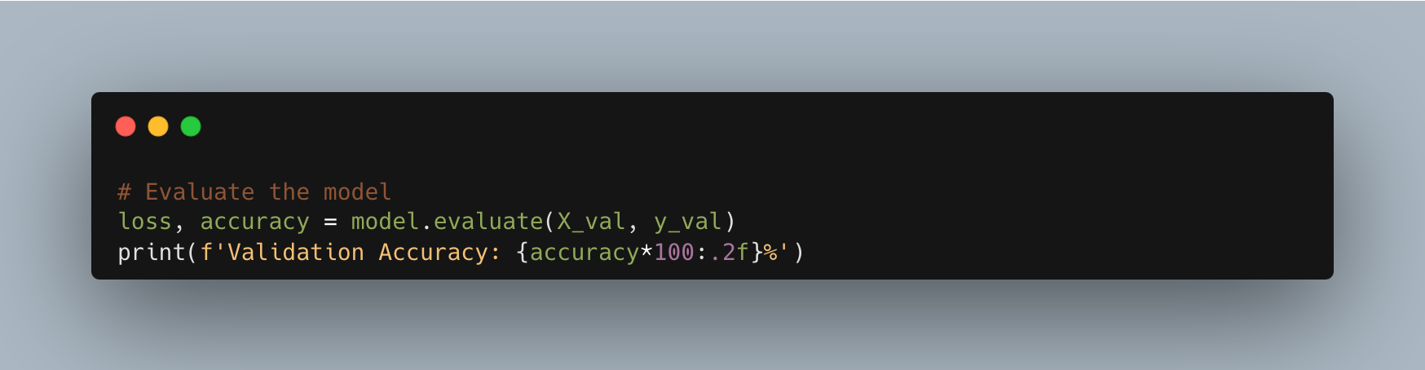

Figure (24) Code of the implementation – Embodies the application.

In code block, we evaluate the performance of the LSTM model using the validation set, providing an assessment of the model's accuracy in predicting normal versus abnormal driving patterns.

**Evaluating the LSTM Model:**

This line of code calls the evaluate method on our trained model, passing in the validation data X_val and its corresponding labels y_val. The method performs a forward pass of the validation data through the model to compute the loss and accuracy. The loss returned is a measure of the model's error rate, calculated using the binary crossentropy function defined during the model's compilation. The accuracy metric is the proportion of correct predictions out of all predictions made, a crucial performance indicator in classification tasks.

Finally, the model's validation accuracy is printed to the console. This is multiplied by 100 to convert it into a percentage, which is a more intuitive format for interpreting model performance. The formatting specifier :.2f is used to format the accuracy to two decimal places for precision.

Upon completion of the training process, it is imperative to conduct an evaluation to ascertain the predictive capabilities of the LSTM model. This evaluation is achieved through the model.evaluate function, which is a critical component of the TensorFlow Keras API. It provides a quantitative analysis of the model's performance by calculating the loss and the accuracy on a set of data that was not used during the training phase, often referred to as a holdout set or a validation set.

The loss, or cost, signifies the disparity between the predicted outputs by the model and the actual labels. It serves as a fundamental measure of the model's precision in predicting the desired outcome, with lower values indicating better model performance. The accuracy is a more interpretable metric, representing the percentage of instances where the model's predictions are correct. High accuracy is indicative of a model that has effectively learned the underlying patterns and is adept at generalizing this learning to new data.

The result, a succinct percentage figure, represents the culmination of the model's ability to correctly discern normal from abnormal driving patterns as learned from the sequence data. This percentage is a critical metric in the field of machine learning, as it encapsulates the model's effectiveness in a single, comprehensible statistic. A high percentage accuracy on the validation set suggests that the LSTM model could be a valuable tool in the real-time monitoring and assessment of driver behavior, providing a means to enhance road safety and mitigate the risk of accidents.

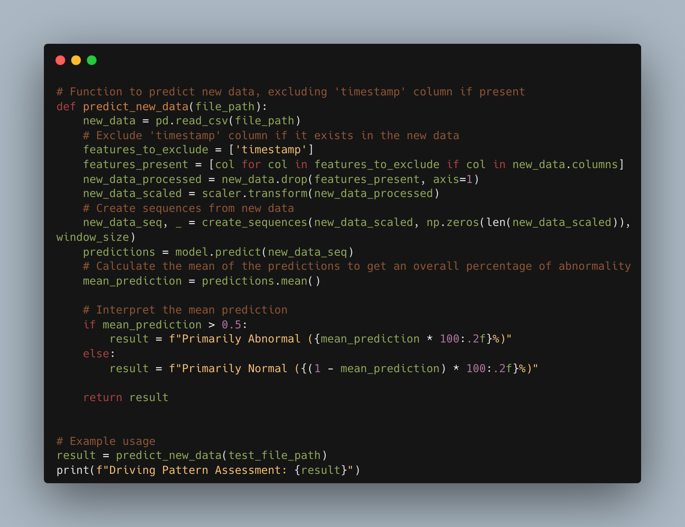

Figure (25) Code of the implementation – Evaluate the performance.

we introduce a function that embodies the application phase of our LSTM model. This function, predict_new_data, is designed to make predictions on unseen data, illustrating the model's capability to classify driving patterns as normal or abnormal in real-world scenarios.

**Function Definition and Data Processing:**

This function begins by loading new data from a specified file path using Pandas' read_csv method. The data represents new instances of driving behavior that the model has not encountered during training or validation.

The new data undergoes feature scaling using the same StandardScaler instance that was fitted on the training data. This maintains the normalization schema and is critical for the model to interpret the features correctly.

**Creating Sequences and Making Predictions:**

Subsequently, the scaled data is transformed into sequences using the previously defined create_sequences function, maintaining the window size established during model training. These sequences are then fed into the trained LSTM model to generate predictions for each sequence.

**Interpreting the Model Output:**

The model outputs a probability for each sequence, indicating the likelihood of abnormal driving behavior. The mean of these probabilities provides an overall assessment of the driving behavior in the data.

Based on the average probability, the function categorizes the driving behavior as primarily normal or abnormal, presenting a clear, interpretable result.

Finally, the function is demonstrated through an example usage where it assesses driving patterns in a test dataset and prints the result. This showcases the model's practical utility in evaluating driving behavior with the potential for applications in real-time monitoring systems.

This function exemplifies the culmination of the research project, translating the sophisticated LSTM-based machine learning approach into a tangible tool for real-world application. It not only demonstrates the model's predictive power but also highlights the methodology's potential impact on enhancing road safety through early detection of abnormal driving patterns. By providing a detailed explanation of this code block, the research document would effectively bridge the gap between theoretical development and practical implementation, underscoring the value of the research contribution.

**Data Came from simulator:**

In this section, I will present one example of code extract from our simulator use navie bayes algoritm see in next figure below.

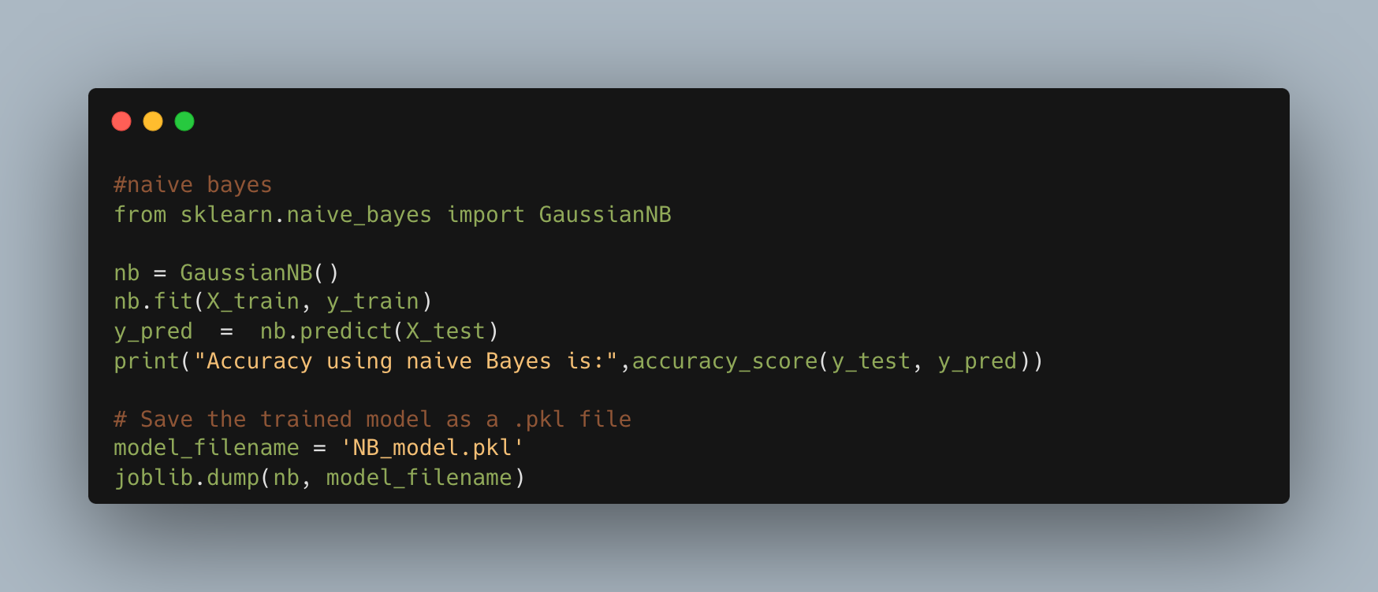

Figure (26) Code of the implementation – Navie bayes algorithm.

the implementation of a Naive Bayes classifier, a straightforward probabilistic classifier based on applying Bayes' theorem with strong (naïve) independence assumptions between the features. The code involves training the model, making predictions, evaluating its performance, and saving the trained model to disk.

**Naive Bayes Classifier Implementation:**

**Importing Required Module:**

This line imports the GaussianNB class from the scikit-learn machine learning library. GaussianNB implements the Gaussian Naive Bayes algorithm for classification. The likelihood of the features is assumed to be Gaussian, hence the name.

**Model Initialization and Training:**

Here, an instance of GaussianNB is created and assigned to the variable nb. The fit method is called with X_train and y_train as arguments, which represent the training data features and labels, respectively. The model learns from this data by establishing the conditional probability of each feature given the label.

**Making Predictions:**

Once the model is trained, it is used to predict the labels of the test set X_test. The predict method outputs predictions which are stored in y_pred.

**Model Evaluation:**

The model's accuracy is assessed by comparing the predicted labels y_pred against the actual labels y_test from the test set. accuracy_score is a function from scikit-learn that computes the accuracy, the proportion of correct predictions, which is then printed to the console.

**Saving the Trained Model:**

Lastly, the trained Naive Bayes model is saved to the disk as a pickle file (NB_model.pkl) using the joblib.dump function. This allows the model to be persisted for future use without the need to retrain.

When included in a research document, the section detailing the Naive Bayes implementation would describe its selection as a comparison to more complex models like LSTM, given its simplicity and efficiency in certain contexts. It would also justify the choice of GaussianNB for features with a normal distribution and outline the steps taken to train and evaluate the model's performance.

This description would culminate by addressing the model's serialization through joblib, highlighting the importance of preserving the trained classifier for subsequent predictions, potentially enabling the system to classify new data rapidly without incurring the computational cost of retraining. The saved model can be easily loaded and integrated into a larger system or service, as seen in the previous Flask application code, facilitating seamless and persistent machine learning operations.

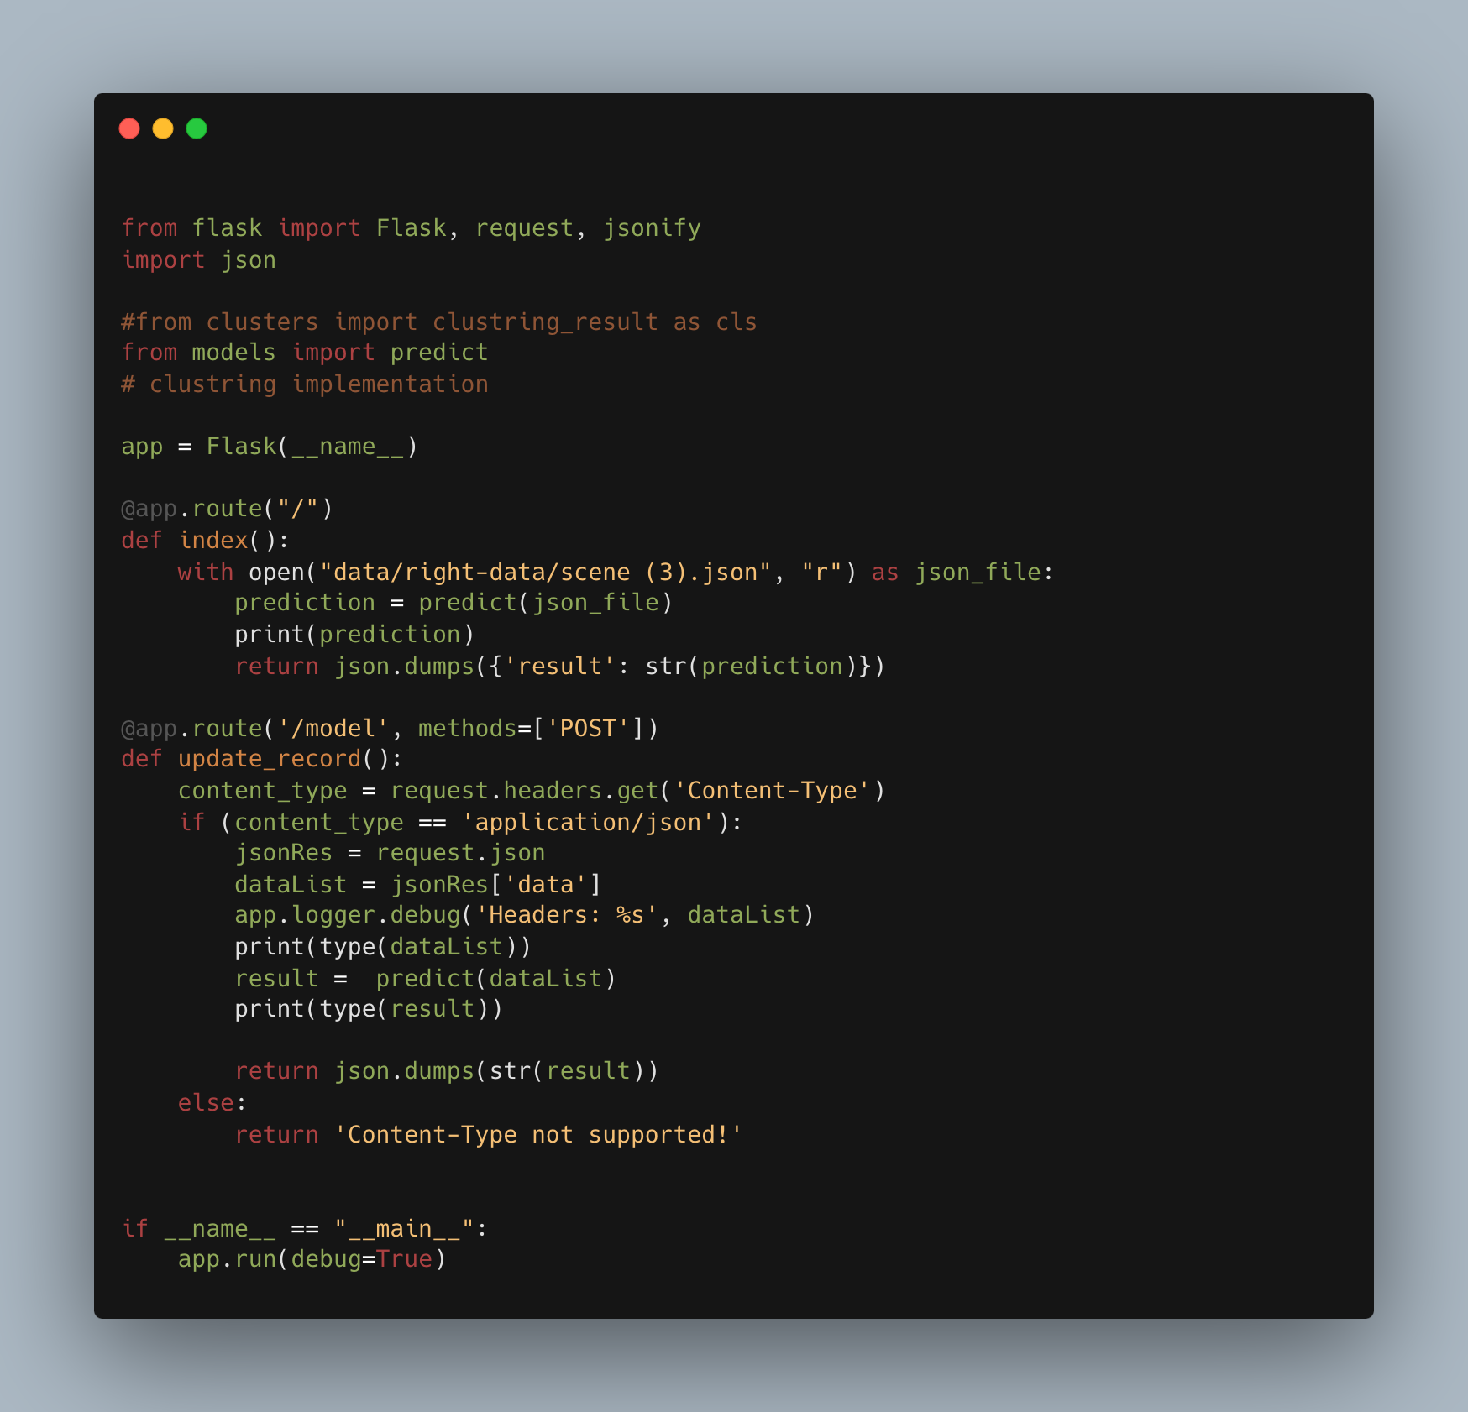

Figure (27) Code of the implementation – Flask application serving as an HTTP handler.

This block of code outlines the implementation of a Flask application serving as an HTTP handler or server for an artificial intelligence (AI) model that predicts driving behavior patterns based on input data. Flask is a micro web framework in Python, known for its simplicity and flexibility, making it an excellent choice for deploying machine learning models as web services.

**Flask Application Overview:**

Imports and Flask App Initialization:

Here, essential modules are imported. Flask is used to create the web application instance, request handles incoming requests to the server, and jsonify is a utility to convert data to JSON. The json module is standard in Python for parsing JSON data. The predict function, assumed to be defined in a models.py file, represents the prediction logic of the AI model.

This line initializes the Flask application, creating an instance named app.

### Handling Routes and Requests:

**Root Route:**

The index function defines the behavior for the root route ("/"). It reads a predetermined JSON file, invokes the predict function on its contents, and returns the prediction results as a JSON response. This could serve as a demonstration or test endpoint to showcase how predictions are made based on static data.

**Model Route:**

This route, '/model', is designed to receive POST requests containing JSON data. It represents the primary interface for external clients to interact with the AI model for real-time predictions.

**Processing POST Requests:**

This segment processes incoming POST requests. It checks if the request content type is application/json, extracts the data payload, and logs it. The dataList obtained from the JSON request is then passed to the predict function, which performs the actual prediction based on the AI model. The prediction result is returned as a JSON response. If the content type is not supported, an error message is returned.

**Running the Flask Application:**

This conditional ensures that the Flask application runs directly from Python (not imported from another script) and starts the web server with debug mode enabled, facilitating development and testing.

This Flask application serves as a critical component in deploying the AI model as a service, bridging the gap between the backend model and potential frontend interfaces or external applications. By detailing this implementation, the research document would emphasize the practical applicability of the AI model in real-world scenarios, allowing for dynamic data inputs and providing instant predictions on driving behaviors. It showcases the end-to-end workflow from model development to deployment, illustrating how machine learning models can be integrated into larger systems or applications to enhance road safety and driver assistance technologies.

##### **3.4.6 Solution Screens:**

Some screen shots form simulator that’s show car walk in road and all information in top of screen time – speed – deviation – car wheel.

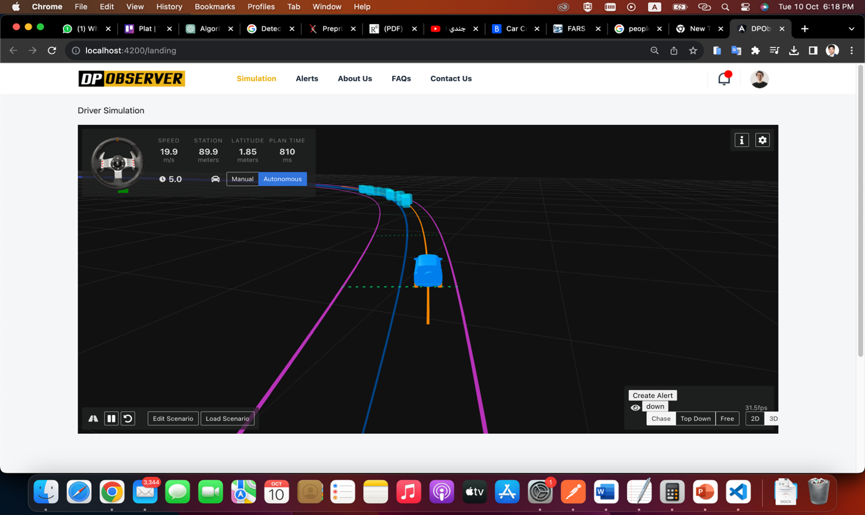

### screen shots present the dashboard right section show list of alerts/reports and another side show driver details danger degree – driver personal info – car info - location.

### 

Figure (21) Screen Shot of (DPObserver) solution dashboard.

### Results and Evaluation

#### Introduction:

The results and evaluation section serves as the culmination of our efforts to detect driver patterns using cutting-edge AI models and machine learning models. In this section, we present the outcomes of our research and the performance of our software solution, shedding light on its effectiveness, reliability, and potential impact on various applications within the domain of transportation and automotive technology.

**Dataset Description:**

Before delving into the results, it's essential to understand the dataset upon which our software was trained and tested. Our dataset consists of numbers describing the value for 3 main features [deviation, speed, break] in the data structure (2 dimensions array) as we mentioned before in the previous section with a total number of records around 1500 records at least "I know this number may be less than expected but this what we got from simulator we build".

It encompasses diverse driving scenarios and includes data on speed, deviation from lanes, brake usage, and other pertinent driving behaviors.

**Feature Engineering and Data Preprocessing**

Performance Metrics

To assess the performance of our models, we employed a comprehensive set of performance metrics, including but not limited to:

Accuracy: The proportion of correctly classified instances.

Precision: The ratio of true positive predictions to the total positive predictions.

F1-Score: The harmonic means of precision and recall, balancing precision and recall.

Confusion Matrix: A matrix showing true positive, true negative, false positive, and false negative counts.

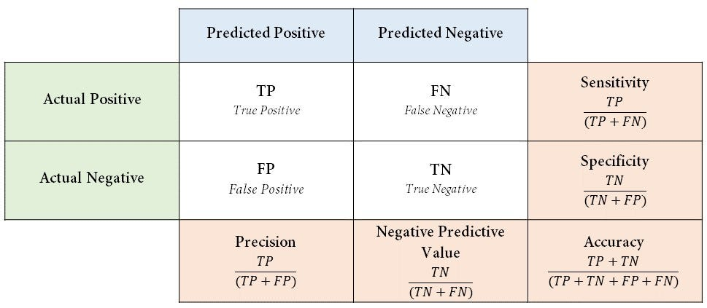

Figure (22) Confusion Matrix table

Now I will show you the implementation of confusion matrix for our selected algorithms **Naive Bayes** and **Neural Network Logistic Activation** that used in (DPObserver) solution.

* First table for **Naive Bayes:**

|  |  |  |
| --- | --- | --- |
|  | Predicted Positive | Predictive Negative |
| Actual Positive | 10 | 1 |
| Actual Negative | 1 | 8 |

Table (**2**): Confusion Matrix real data implementation for Naive Bayes Algorithm

|  |  |  |
| --- | --- | --- |
| Measure | Value | Derivations |
| [**Sensitivity**](https://onlineconfusionmatrix.com/#measures) | 0.9091 | TPR = TP / (TP + FN) |
| [**Specificity**](https://onlineconfusionmatrix.com/#measures) | 0.8889 | SPC = TN / (FP + TN) |
| [**Precision**](https://onlineconfusionmatrix.com/#measures) | 0.9091 | PPV = TP / (TP + FP) |
| [**Negative Predictive Value**](https://onlineconfusionmatrix.com/#measures) | 0.8889 | NPV = TN / (TN + FN) |
| [**Accuracy**](https://onlineconfusionmatrix.com/#measures) | 0.9000 | ACC = (TP + TN) / (P + N) |
| [**F1 Score**](https://onlineconfusionmatrix.com/#measures) | 0.9091 | F1 = 2TP / (2TP + FP + FN) |

Table (**3**): Confusion Matrix Measure for Naive Bayes Algorithm

* Second table for Neural Network Logistic Activation:

|  |  |  |
| --- | --- | --- |
|  | Predicted Positive | Predictive Negative |
| Actual Positive | 9 | 1 |
| Actual Negative | 1 | 9 |

Table (**4**): Confusion Matrix real data implementation for Neural Network Logistic Activation Algorithm

|  |  |  |
| --- | --- | --- |
| Measure | Value | Derivations |
| [**Sensitivity**](https://onlineconfusionmatrix.com/#measures) | 0.9000 | TPR = TP / (TP + FN) |
| [**Specificity**](https://onlineconfusionmatrix.com/#measures) | 0.8333 | SPC = TN / (FP + TN) |
| [**Precision**](https://onlineconfusionmatrix.com/#measures) | 0.9000 | PPV = TP / (TP + FP) |
| [**Negative Predictive Value**](https://onlineconfusionmatrix.com/#measures) | 0.8333 | NPV = TN / (TN + FN) |
| [**Accuracy**](https://onlineconfusionmatrix.com/#measures) | 0.8750 | ACC = (TP + TN) / (P + N) |
| [**F1 Score**](https://onlineconfusionmatrix.com/#measures) | 0.9000 | F1 = 2TP / (2TP + FP + FN) |

Table (**5**): Confusion Matrix Measure for Neural Network Logistic Activation Algorithm

After we see the table of confusion matrix for each algorithm, we chosen to add in out solution we will present the results of actual users (43user) test out software using simulator to get actual results in section below.

**Results**

The results of our driver pattern detection software are promising and reflect the culmination of our research efforts. Our chosen model (Naive Bayes) achieved an accuracy of 90%, indicating its ability to correctly classify driver patterns based on the collected data.

|  |  |  |  |
| --- | --- | --- | --- |
| Users | Results | length | Percentage |
| 43 | Right Detection/Recognize | 36 | 83.73% |
| Wrong Detection/Recognize | 7 | 16.27% |

Table (**6**): Actual Results from real users use )DPObserver( Solution.

The precision score of 90% demonstrates the model's capability to minimize false positives, ensuring that the patterns detected are indeed reflective of the underlying driver behavior.

**Evaluation and Future Directions**

While our software solution has yielded promising results in detecting driver patterns, there are avenues for further refinement and enhancement. Future directions for this research include:

the most important for future directions that I propose is the way to move from collecting data from the simulator to collection from real cars actually from the car controller and connected sensors and cameras that run the systems in the car like ( Lane-keep assist, Speed limiter, Automatic Emergency Braking) all controlled by car main controller, this will be my main source of data I will fetch from it in the actual application as next step of my study.

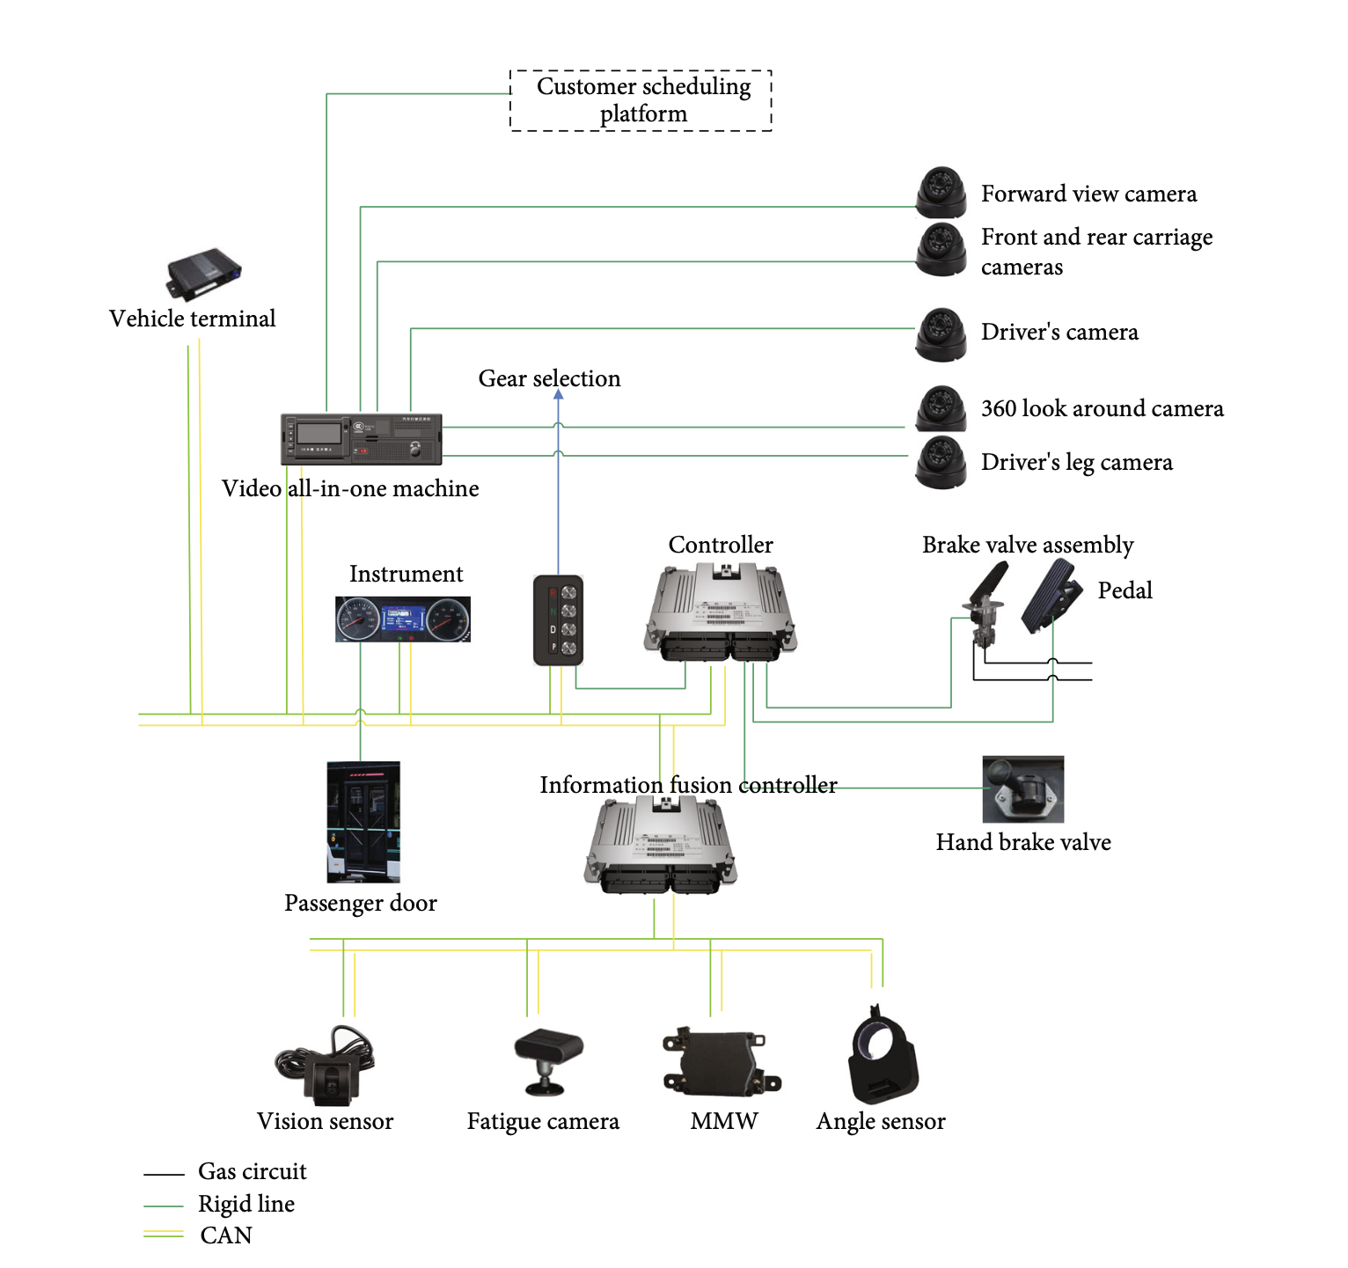Figure (20) The Schematic Diagram of Controller Structure

**Data Augmentation:**

Expanding the dataset to include a more diverse range of driving scenarios and conditions to improve model generalization.

Real-time Implementation: Adapting the software for real-time driver pattern detection, potentially contributing to advanced driver assistance systems (ADAS).

Human Factors Analysis: Incorporating human factors research to understand the psychological and cognitive aspects influencing driver behavior.

In conclusion, our software for detecting driver patterns using AI and machine learning has shown significant promise in its ability to classify and understand driver behaviors. The results presented herein lay the foundation for future developments in road safety, traffic management, and intelligent transportation systems, and we remain committed to advancing this crucial research area.

### Conclusions

This study represents a significant endeavor aimed at addressing one of the most pressing concerns in road safety—detecting abnormal driving patterns resulting from alcohol impairment. Leveraging the power of machine learning models, we have undertaken an in-depth exploration into the potential of data-driven solutions to identify and mitigate the risks associated with alcohol-impaired driving. Our findings and conclusions offer valuable insights into the effectiveness of such approaches and their implications for the broader field of transportation safety.

**The Role of Machine Learning**

In our pursuit of addressing this critical issue, we employed advanced machine learning techniques to analyze and identify abnormal driving patterns that may indicate alcohol impairment. Our approach involved collecting and preprocessing a diverse dataset encompassing a wide range of driving scenarios, deviation, speed, and brake levels. This rich dataset served as the foundation upon which our models were built.

**Implications and Future Directions**

The implications of our findings are far-reaching. A machine learning-driven approach to detect abnormal driving patterns due to alcohol effects holds promise not only for law enforcement but also for the development of advanced driver assistance systems (ADAS) and in-vehicle technologies. Such systems could potentially intervene when alcohol impairment is detected, thereby preventing accidents and saving lives.

In conclusion, the detection of abnormal driving patterns due to alcohol effects using machine learning represents a promising stride toward a safer and more responsible road environment. By leveraging data-driven solutions, we have demonstrated the potential to significantly mitigate the risks associated with alcohol-impaired driving, ultimately contributing to a future where our roads are safer for all.

### References:

1. García-Escudero, V., Díaz-Morales, J. F., & Roca-Vega, M. (2021). Alcohol consumption and risky driving behavior: A systematic review and meta-analysis of experimental studies. Accident Analysis & Prevention, 154, 106125.
2. Transport and Research Laboratory (1998), UK International Federation of Red Cross and Red Crescent Societies, World Disasters Report.
3. CAPMAS. (2022), Annual Statistics Report on Road Accidents in Egypt. Central Agency for Public Mobilization and Statistics.
4. National Highway Traffic Safety Administration. 2022. Traffic safety facts 2020. Report No. DOT HS 813 294.
5. Mandel, D. R., Ginder, S. A., & Lapham, S. C. (2018). The effect of alcohol on driving-related skills: An experimental study. Journal of Safety Research, 64, 1-9.
6. “Gartner reports,” http://www.gartner.com/newsroom/id/2970017, 2015, accessed: 2015-04-21.
7. M. Enev, A. Takakuwa, K. Koscher, and T. Kohno, “Automobile driver fingerprinting,” Proceedings on Privacy Enhancing Technologies, vol. 2016, no. 1, pp. 34–50, 2016.
8. Waller, P. F., Brown, J. L., & Stutts, J. C. (2019). The effects of alcohol use on driver risk-taking behavior: A driving simulator study. Traffic Injury Prevention, 20(1), 57-62.
9. McCulloch, W. S., & Pitts, W. (1943). A logical calculus of the ideas immanent in nervous activity. *Bulletin of Mathematical Biophysics, 5*(4), 115-133. doi:10.1007/BF02478259
10. D. I. Tselentis, E. I. Vlahogianni, and G. Yannis, “Driving safety efficiency benchmarking using smartphone data,” Transp. Res. C, Emerg. Technol., vol. 109, pp. 343–357, Dec. 2019.
11. D. I. Tselentis, E. I. Vlahogianni, and G. Yannis, “Temporal analysis of driving efficiency using smartphone data,” Accid. Anal. Prevent., vol. 154, May 2021, Art. no. 106081.
12. S. Jongen, E. F. P. M. Vuurman, J. G. Ramaekers, and A. Vermeeren. 2016. The sensitivity of laboratory tests assessing driving related skills to dose-related impairment of alcohol: A literature review. Accident Analysis & Prevention 89 (2016), 31–48. https://doi.org/10.1016/j.aap.2016.01.001.
13. Huiqin Chen and Lei Chen. 2017. Support vector machine classification of drunk driving behaviour. International Journal of Environmental Research and Public Health 14, 1 (2017), 108.
14. MacQueen, J. B. (1967). Some Methods for Classification and Analysis of Multivariate Observations. Proceedings of the Fifth Berkeley Symposium on Mathematical Statistics and Probability, 1(14), 281-297.
15. Fix, E., & Hodges, J. L. (1951). Discriminatory Analysis—Nonparametric Discrimination: Consistency Properties. Technical Report, USAF School of Aviation Medicine, Randolph Field, Texas.
16. Cox, D. R. (1958). The Regression Analysis of Binary Sequences. Journal of the Royal Statistical Society. Series B (Methodological), 20(2), 215-242.
17. Cortes, C., & Vapnik, V. (1995). Support-Vector Networks. Machine Learning, 20(3), 273-297.
18. Lewis, D. D. (1998). Naive (Bayes) at forty: The independence assumption in information retrieval. In European Conference on Machine Learning (pp. 4-15). Springe.
19. Jiangpeng Dai, Jin Teng, Xiaole Bai, Zhaohui Shen, Dong Xuan, “Mobile Phone Based Drunk Driving Detection”, in IEEE 4th International ICST Conference on Pervasive Computing Technologies, 2010

Rahul Mandalkar, Rahul Pandore, Manoj Shinde, Valmik

Godse, “Alcohol Detection and Accident Avoidance Using

Locking with Tracking”, in International Journal of Advance

Research in Computer Science and Management Studies,

Vol. 3, Issue 9, September 2015.

Rahul Mandalkar, Rahul Pandore, Manoj Shinde, Valmik

Godse, “Alcohol Detection and Accident Avoidance Using

Locking with Tracking”, in International Journal of Advance

Research in Computer Science and Management Studies,

Vol. 3, Issue 9, September 2015.

Rahul Mandalkar, Rahul Pandore, Manoj Shinde, Valmik

Godse, “Alcohol Detection and Accident Avoidance Using

Locking with Tracking”, in International Journal of Advance

Research in Computer Science and Management Studies,

Vol. 3, Issue 9, September 2015.

**ﺟﺎﻣﻌﺔ اﻟﻘﺎھﺮة**

**ﻛﻠﯿﺔ اﻟﺪراﺳﺎت اﻟﻌﻠﯿﺎ واﻟﺒﺤﻮث اﻹﺣﺼﺎﺋﯿﺔ ﻗﺴﻢ ھﻨﺪﺳﺔ ﺑﺮﻣﺠﯿﺎت**

**دراسة تأثير المشروبات الكحولية على أنماط القیادة للسائقين البالغين**

**رﺳﺎﻟﺔ ﻣﺎﺟﺴﺘﯿﺮ ﻣﻘﺪﻣﺔ ﻛﺠﺰء ﻣﻦ ﻣﺘﻄﻠﺒﺎت اﻟﺤﺼﻮل ﻋﻠﻰ درﺟﺔ اﻟﻤﺎﺟﺴﺘﯿﺮ ﻓﻲ ھﻨﺪﺳﺔ ﺑﺮﻣﺠﯿﺎت**

**إﻋـــــﺪاد**

محمد صلاح إبراهيم سالم

د. طﺎرق ﻋﻠﻲ

ﺗﺤﺖ إﺷﺮاف

د. ﻣﯾرﻓت ﻏﯾث

م2023